Guide
Week | Descriptor | Topic
2 | Numbers, operations and relationships | - Counting forward and backwards 1-30  - Identify, recognise symbols 1-20
3 | Numbers, operations and relationships | - Identify, recognise and read number names
4 | Numbers, operations and relationships | - Describe, compare and order numbers
5 | Space and shape (Geometry) | - Language of position  - Understand the position of one object in relation to another.  - Top, on, front, behind next to and etc.
6 | Space and shape (Geometry) | - Recognise and name 3D shapes.  - Objects in the classroom and pictures.
7 | Space and shape (Geometry) | - Describe, sort and compare 3D shapes in terms of size colour and shape.
8 | Data Handling | - Collect and sort objects according to different size, shape and colour.
9 | Numbers, operations and relationships | Additional work for group 3  - Add numbers to 10  - Subtract from 10 using appropriate symbols (+-=)

Number chart
1 | 2 | 3 | 4 | 5 | 6 | 7 | 8 | 9 | 10
11 | 12 | 13 | 14 | 15 | 16 | 17 | 18 | 19 | 20
21 | 22 | 23 | 24 | 25 | 26 | 27 | 28 | 29 | 30
31 | 32 | 33 | 34 | 35 | 36 | 37 | 38 | 39 | 40
41 | 42 | 43 | 44 | 45 | 46 | 47 | 48 | 49 | 50
51 | 52 | 53 | 54 | 55 | 56 | 57 | 58 | 59 | 60
61 | 62 | 63 | 64 | 65 | 66 | 67 | 68 | 69 | 70
71 | 72 | 73 | 74 | 73 | 73 | 77 | 78 | 79 | 80
81 | 82 | 83 | 84 | 85 | 86 | 87 | 88 | 89 | 90
91 | 92 | 93 | 94 | 95 | 96 | 97 | 98 | 99 | 100

Introduction
Term 2


Week 2


Counting forward and backwards 1-30
Identify, recognise symbols 1-20

Group 1
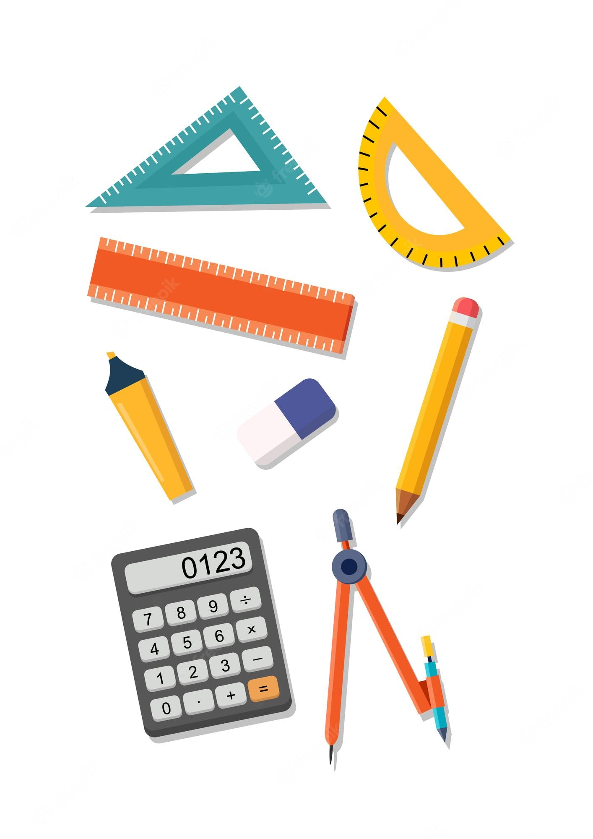
Date: ______________
Count and circle
In each row count and circle the correct number.

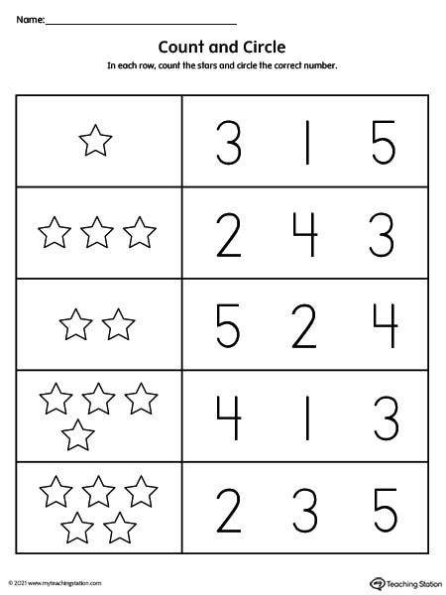
[5 marks]
Date: ______________
Circle the matching number
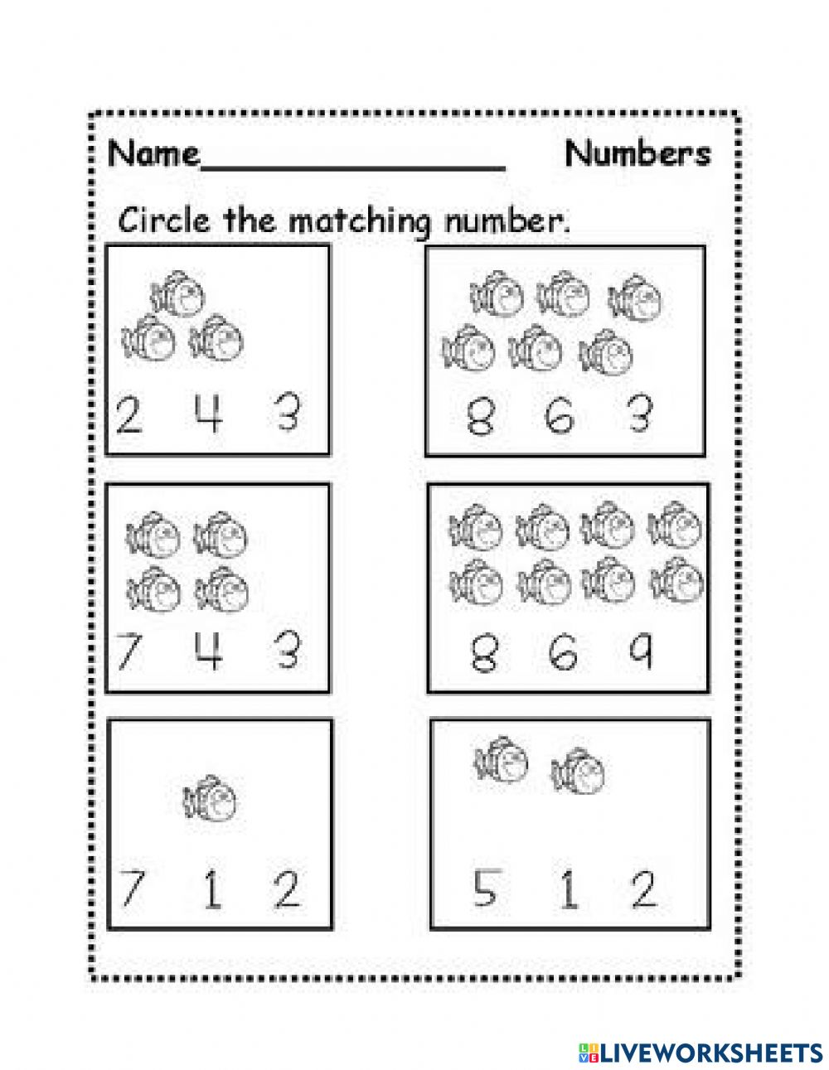

[6 marks]

Date: ______________
Match it up
Draw lines to connect the numbers and pictures that go together.

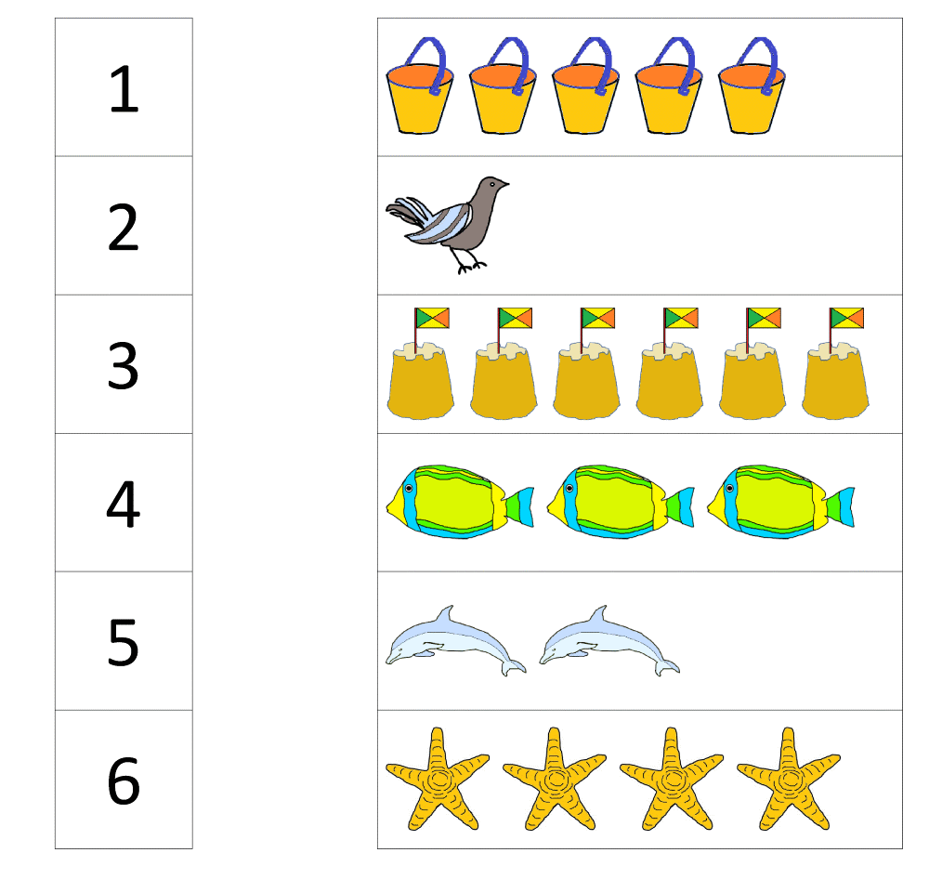
[6 marks]
Group 2
Date: ______________
Show the number
Colour the blocks in each frame to match the number on the bucket.

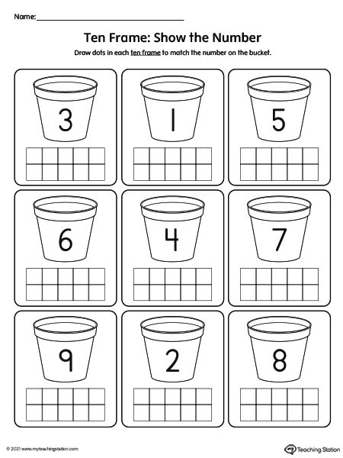

[9 marks]
Date: ______________
Colour and count
Count the pictures, circle the correct number and colour the correct block.
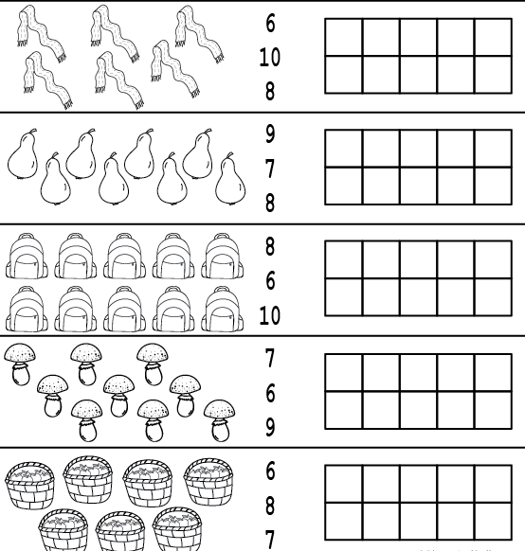

[5 marks]
Date: _____________
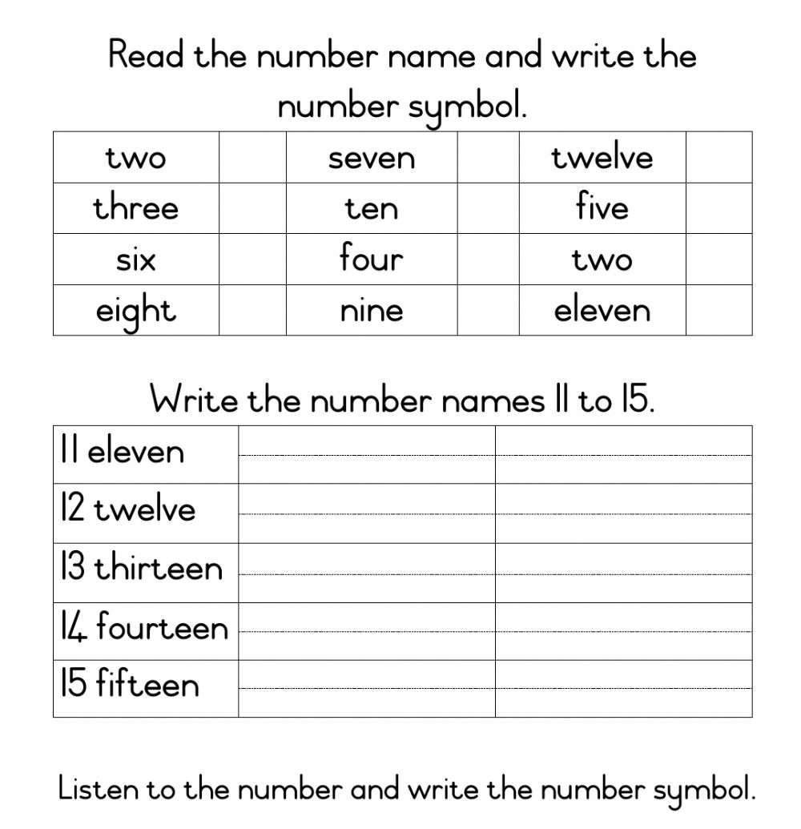 __________________________________________________________ [14 marks]

Date: _____________ backwards numbers 1-30
Count the numbers backward

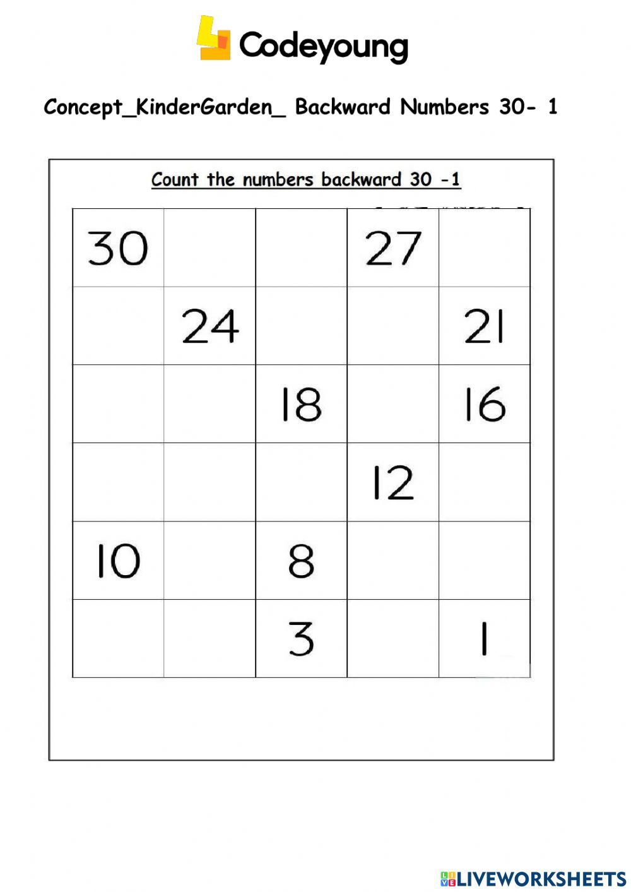
[18 marks]

Group 3
Date: ______________
Counting up to 50
Fill in the blank spots in the chart with the correct number.

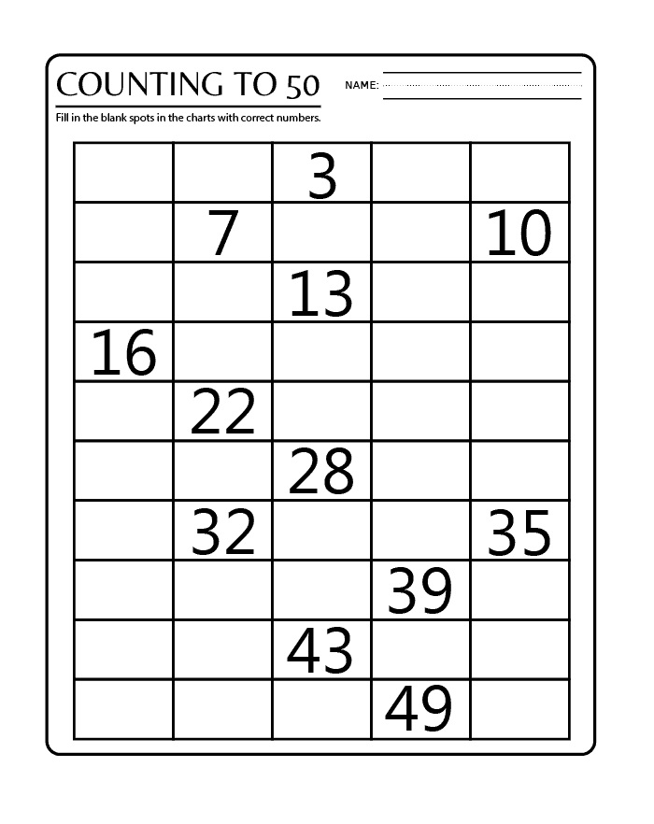
[38 marks]
Date: _______________
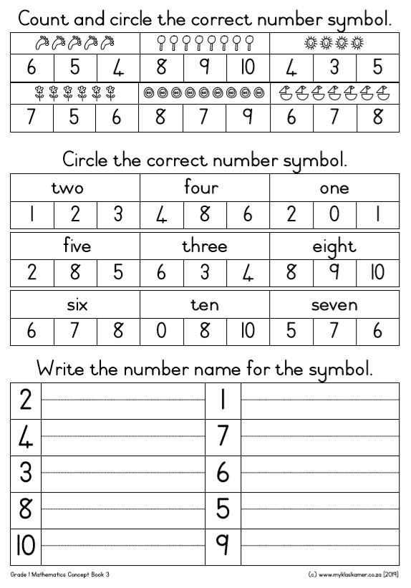
[30 marks]
Date: ______________
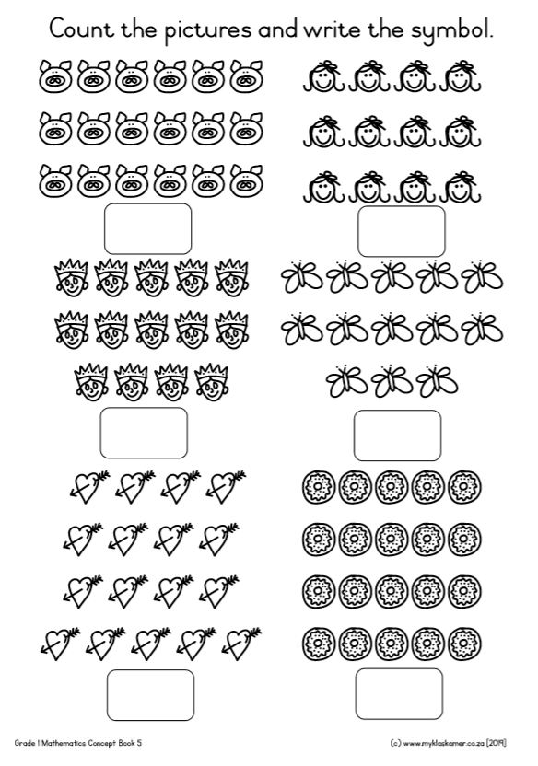
[4 marks]
How many? 1-10
Count the items and write the number in the box from 1-10

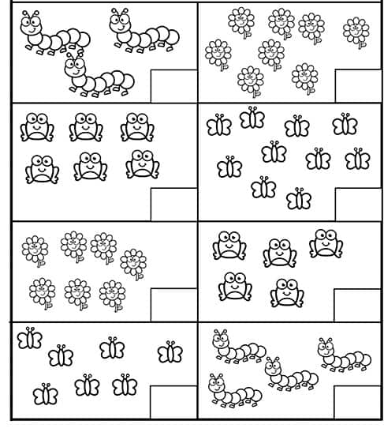
[8 marks]
Week 3

Identify, recognise and read number names

Group 1
Date: _____________
Number match
Match the number with the correct number word.

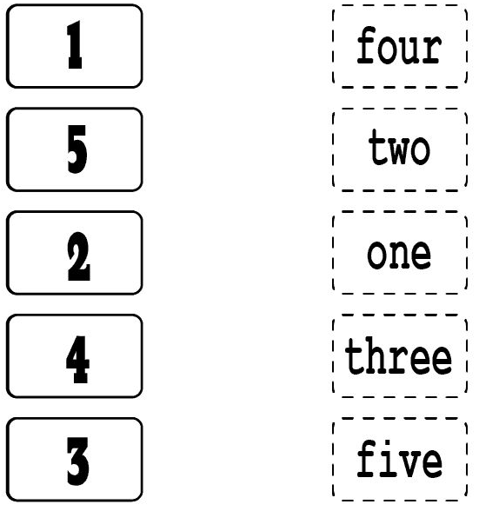
[5 marks]
Date: ______________
Number words
Draw a line from the hands to the matching number words.

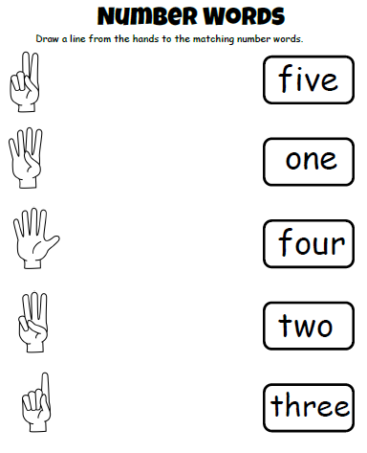
[5 marks]
Date: ______________
Trace the number 8 and colour.
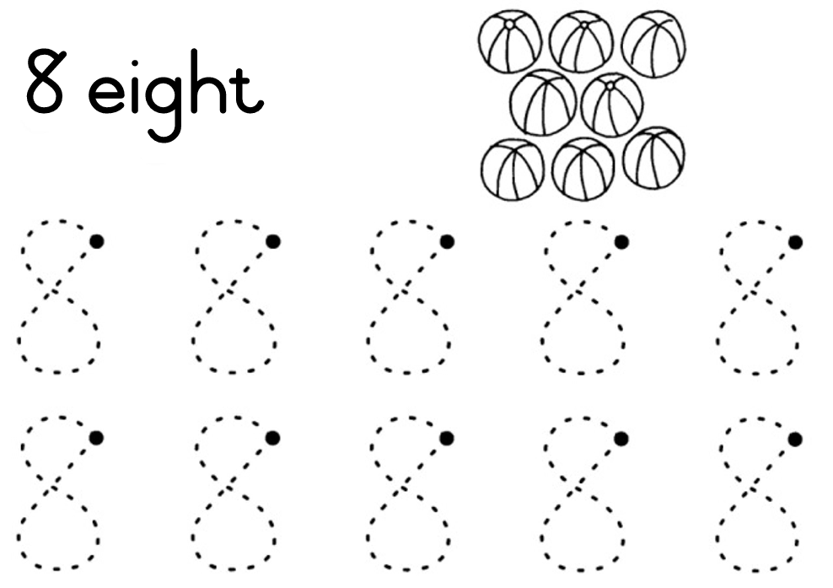
[5 marks]

Group 2
Date: _____________
Numbers in words
Fill in the blanks with the correct answers.

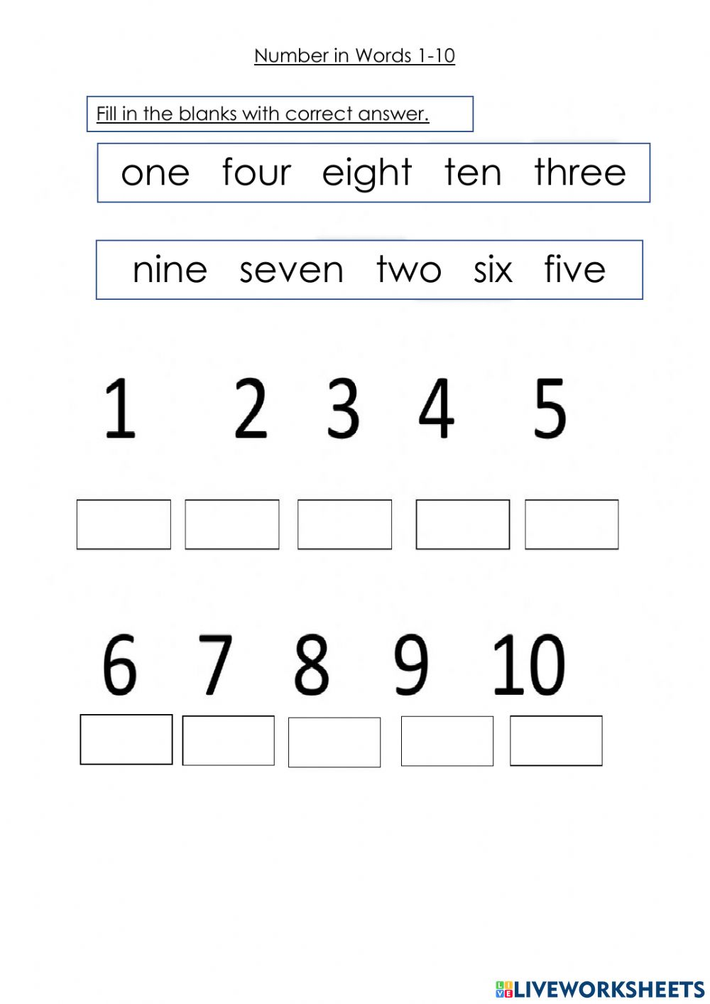

[10 marks]

Date: ____________
Number names
Unscramble the words.

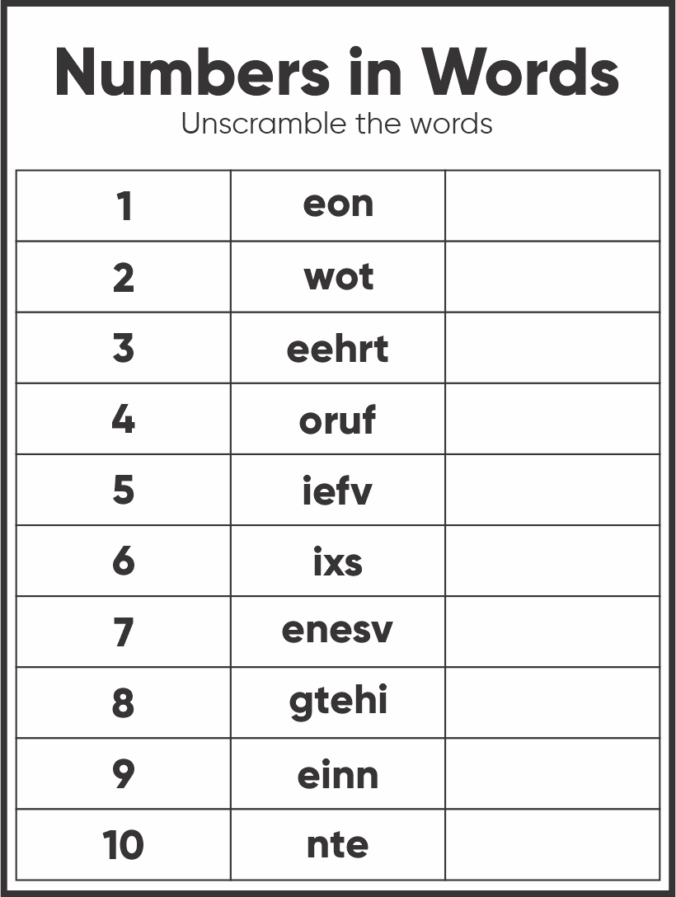
[10 marks]

Date: ______________
Circle the correct number.
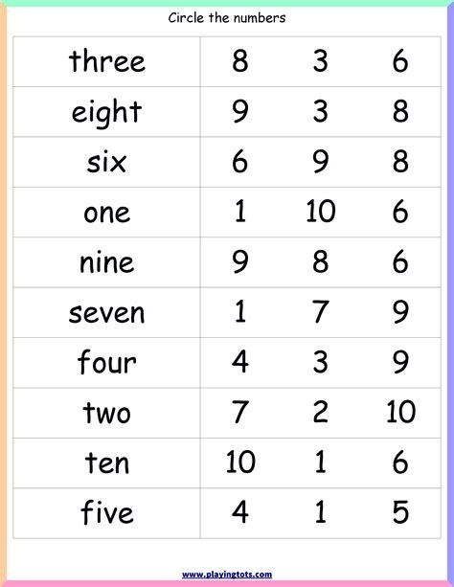
[10 marks]

Group 3
Date:________________
Writing numbers and number names
Write numbers 1-10 and its number name in the space provided.

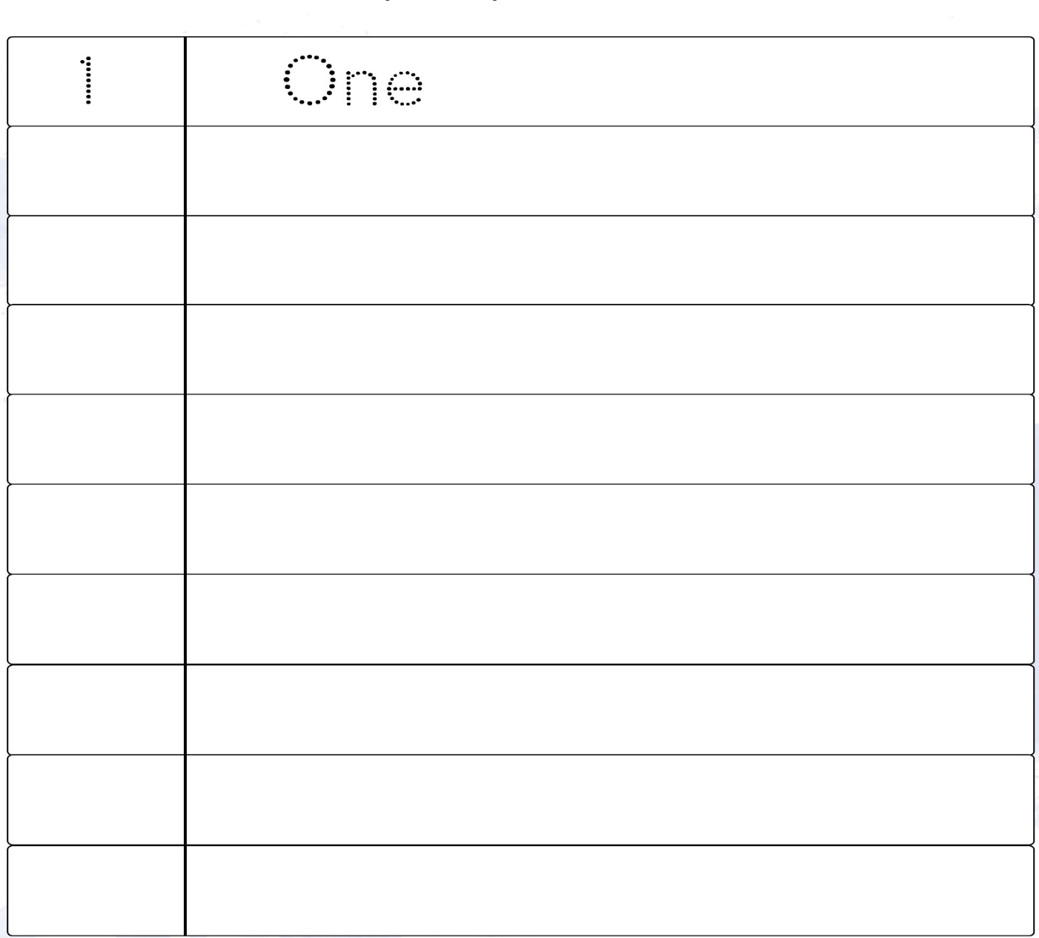
[16 marks]

Date: _______________
Write the number names of counting 1-10.
two | three | four | five
six | seven | eight | nine

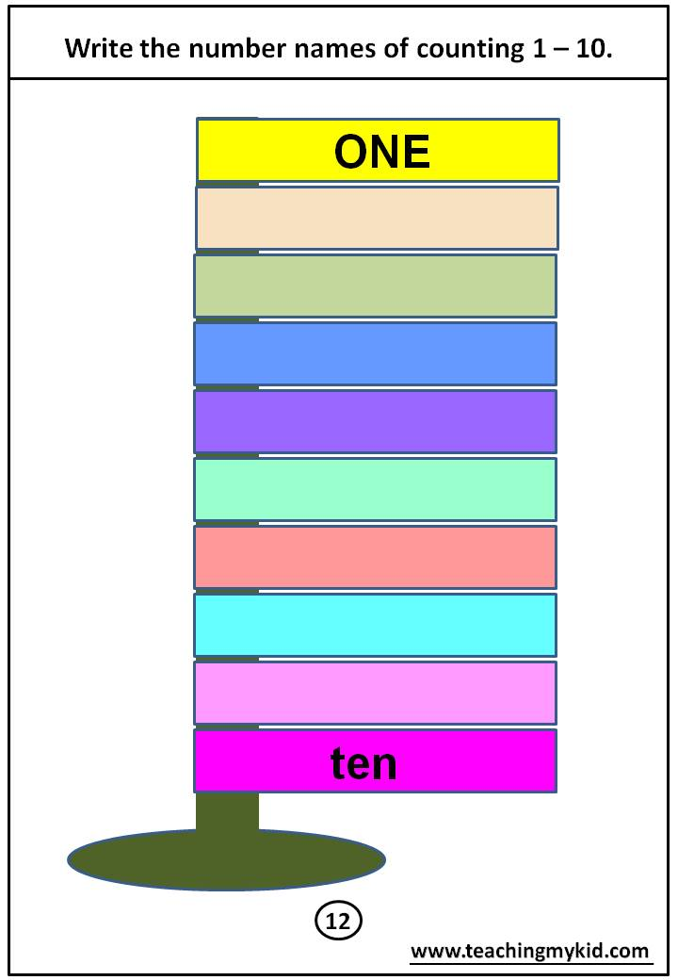 [8 marks]
Date: ______________
Write the numbers in words.
One | two | three | four | five
Six | seven | eight | nine | ten

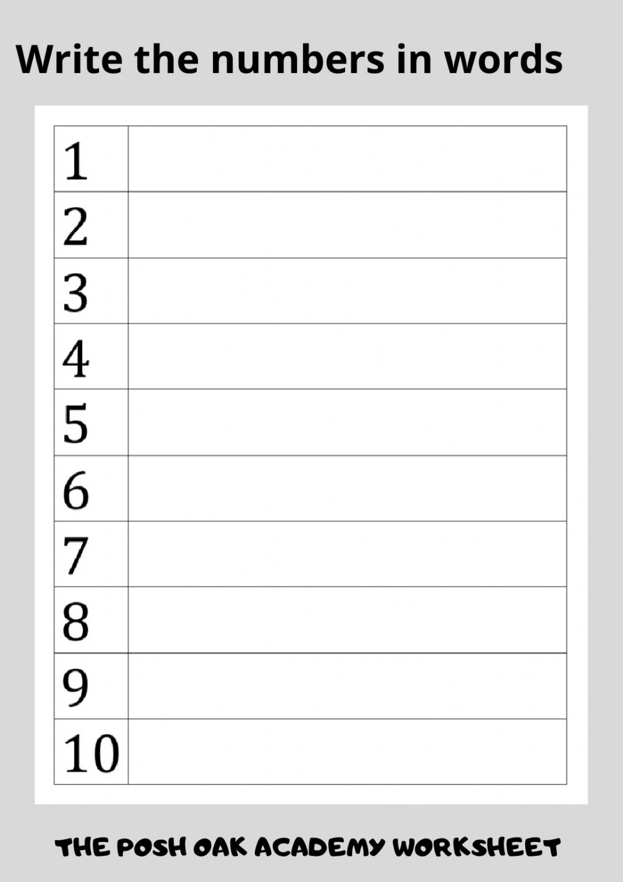
[10 marks]
Week 4

Describe, compare and order numbers
Group 1

Date: ______________
Compare and arrange the numbers
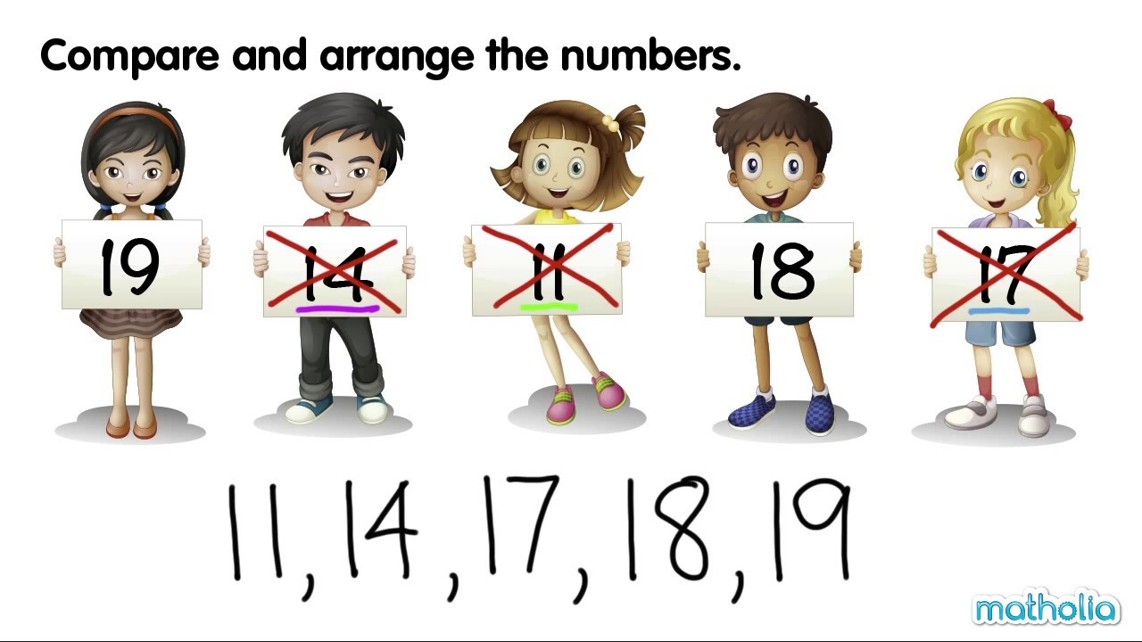

[5 marks]

Date:______________
Count and compare
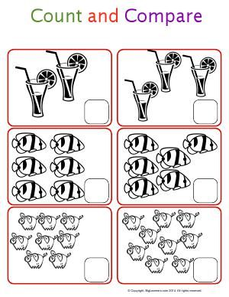

[6 marks]
Date: _______________
Which has the most?
Circle the group with the most.

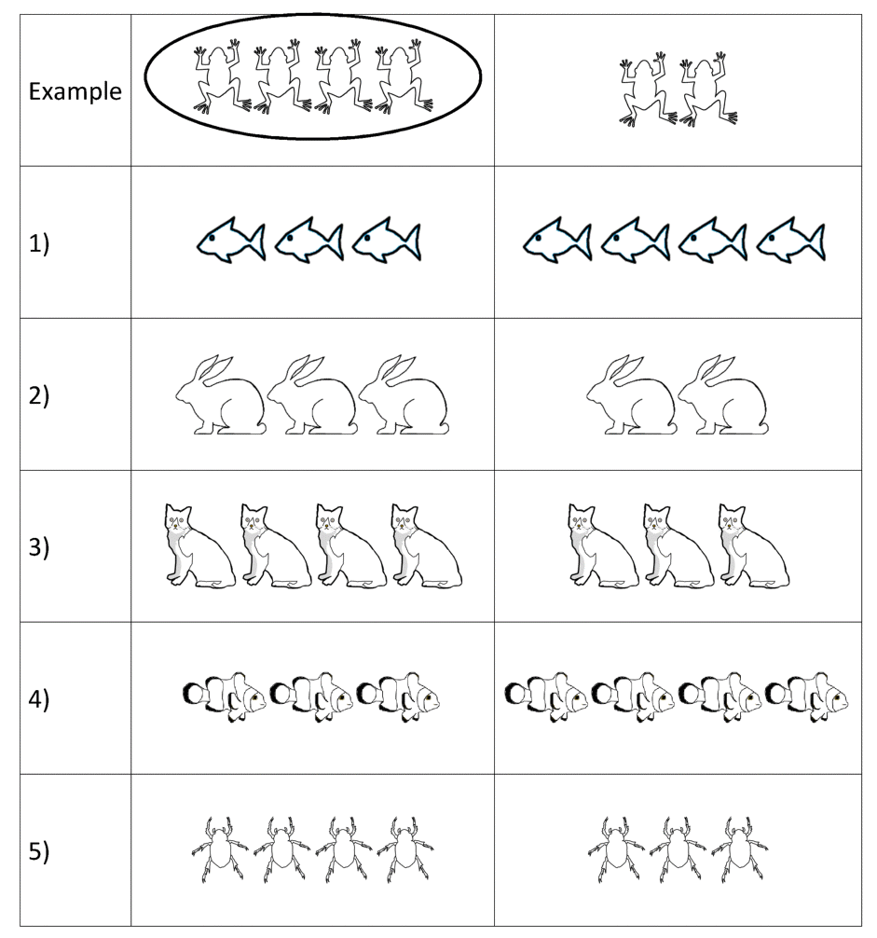
[5 marks]
Group 2
Date: __________________
Comparing pumpkins
Look at each set of pumpkins, colour the pumpkin with the bigger number orange and the pumpkin with the smallest number green.

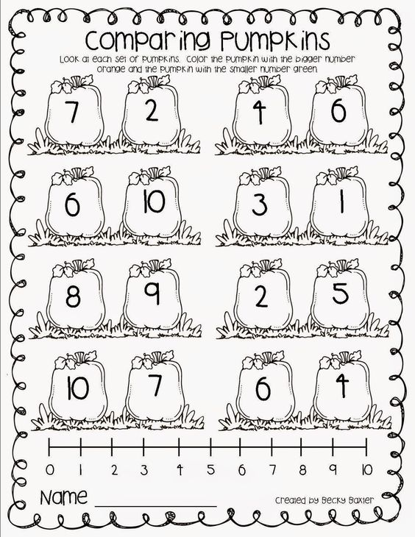
[16 marks]
Date: _____________
Number ordering
Write each set of numbers in the correct order
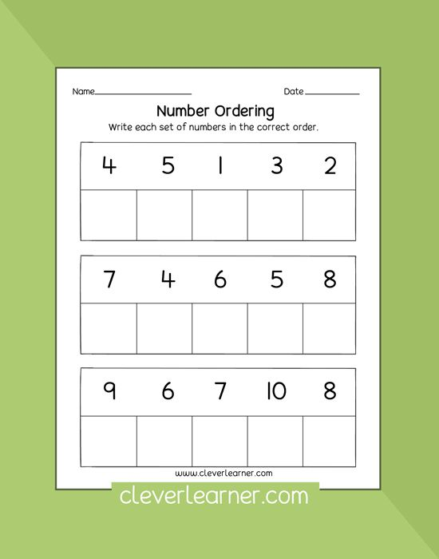
[15 marks]

Date: ___________
Ordering numbers 1-10
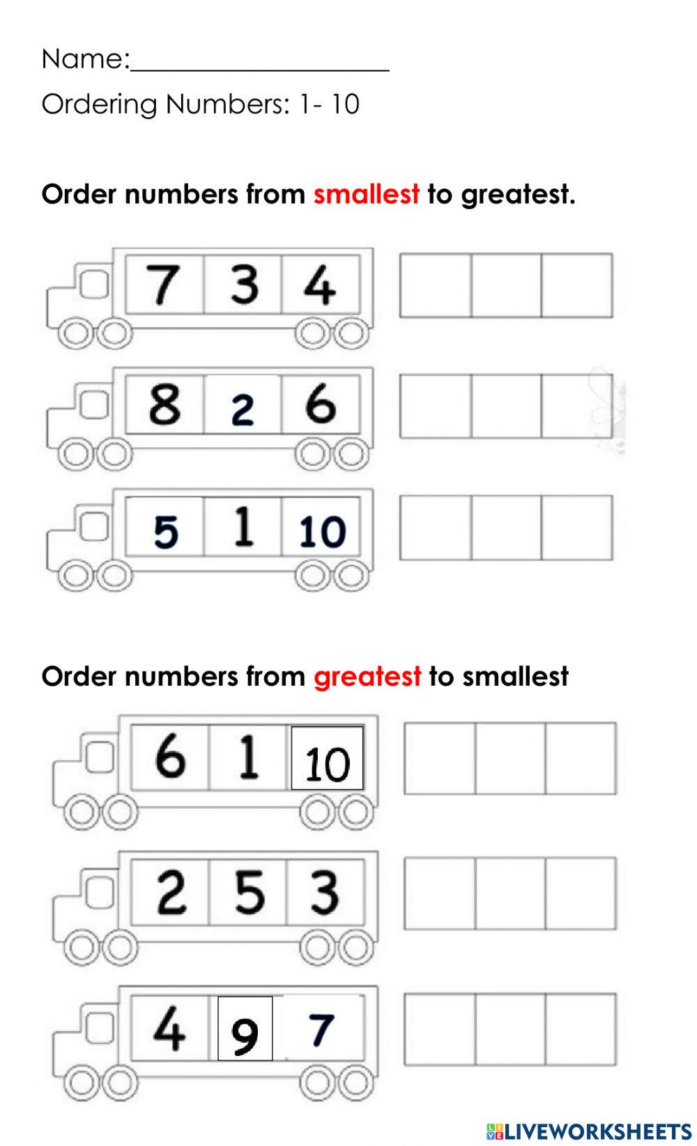
[16 marks]

Group 3
Date: ______________

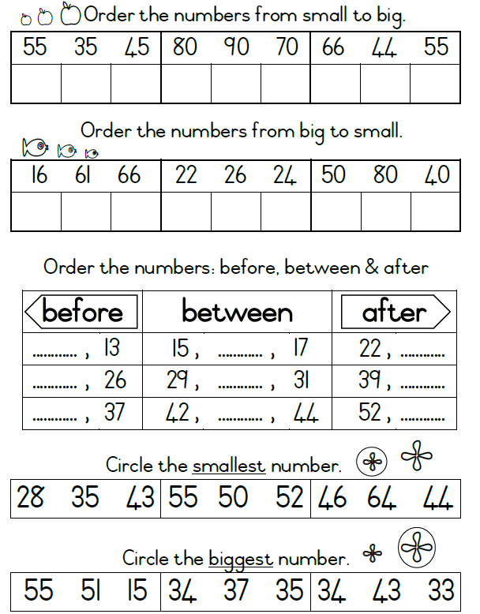
[33 marks]
Date: _____________
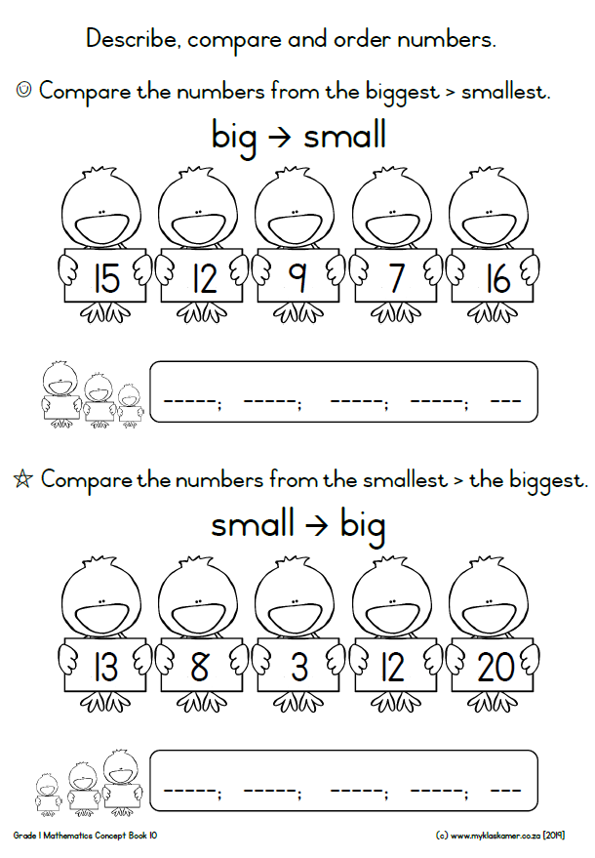
[9 marks]
Date: ______________
Circle the incorrect number in the sequence 1-10.
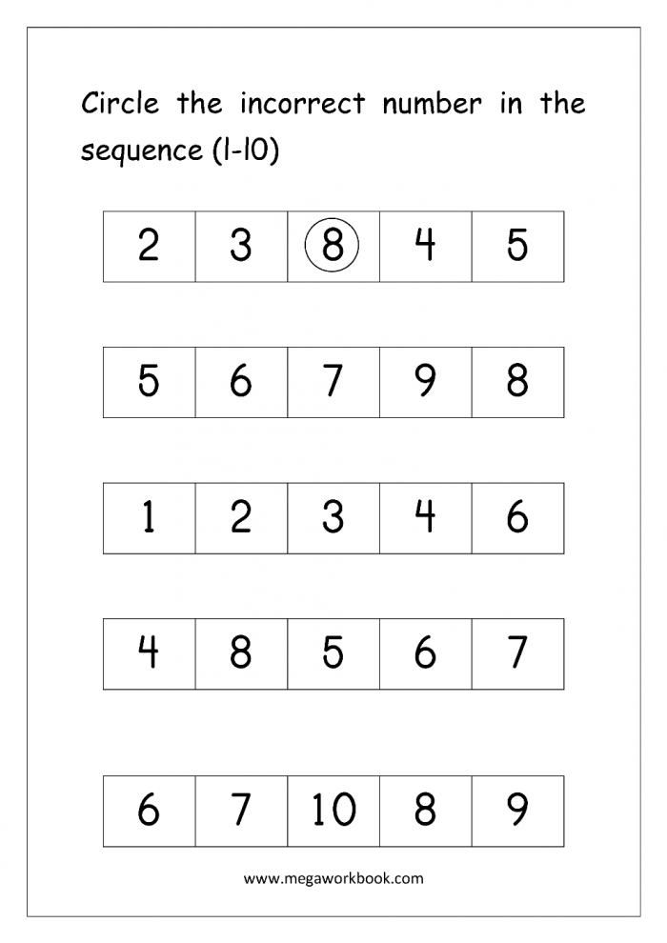
[5 marks]

Week 5

- Language of position
- Understand the position of one object in relation to another.
- Top, on, front, behind next to and etc.

Group 1
Date: ________________
Identify which picture is the tallest in each box and circle it.

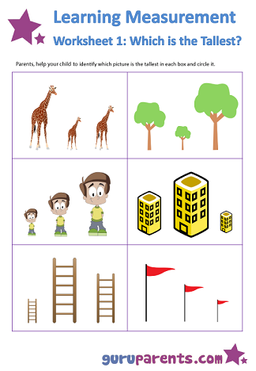
[6 marks]

Date: _____________
Oder the following according to its size.

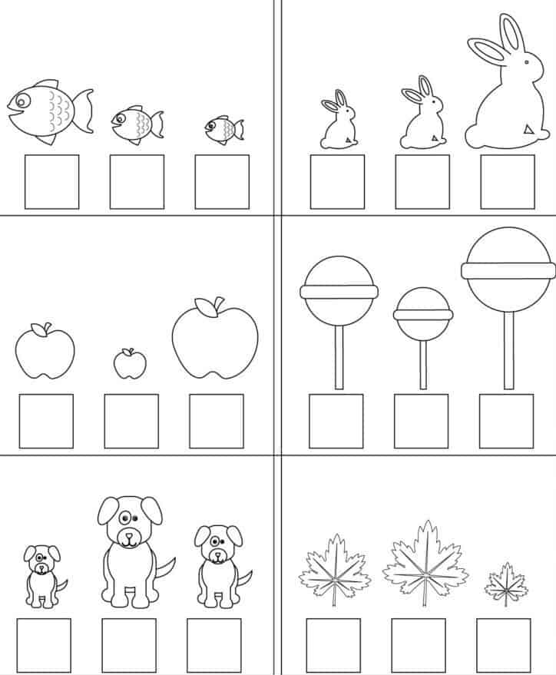

[18 marks]
Date: _______________
Comparing length
Tick the correct answer.

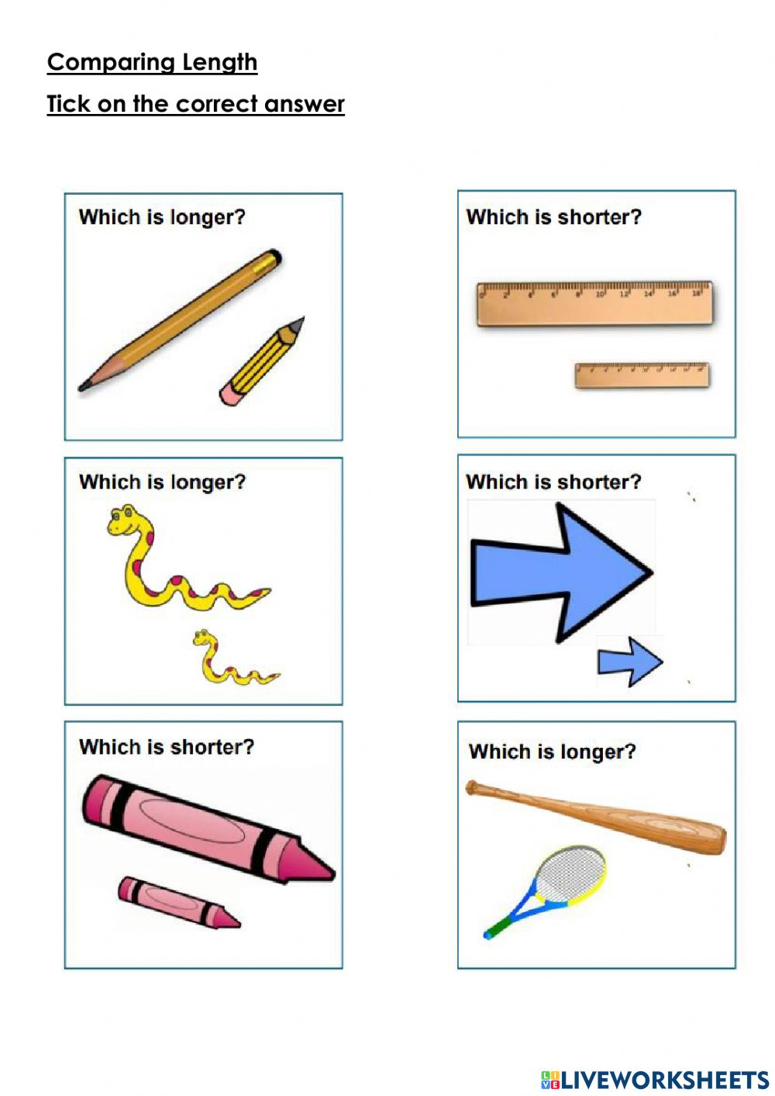
[8 marks]

Group 2
Date: _________________
Length
Number each set of items from 1 to 3. 1 being the shortest and 3 being the longest.

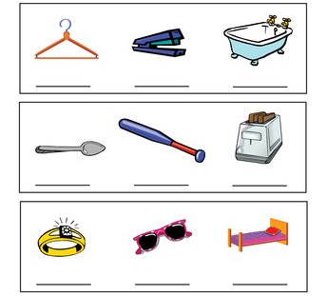
[9 marks]

Date: _________________
Which of these objects is the long, longer and longest?
long | longer | longest

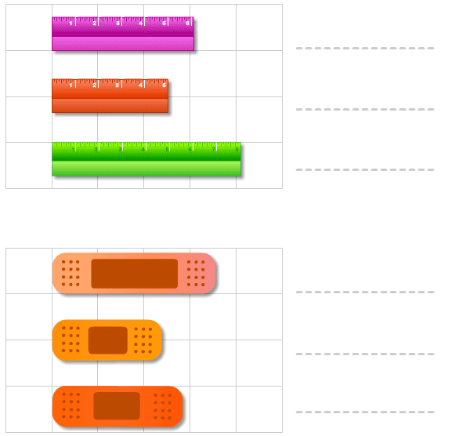
[6 marks]

Date: _______________
Order by length
Compare the lengths of the given objects and write 1, 2, or 3 in the blanks to arrange by length

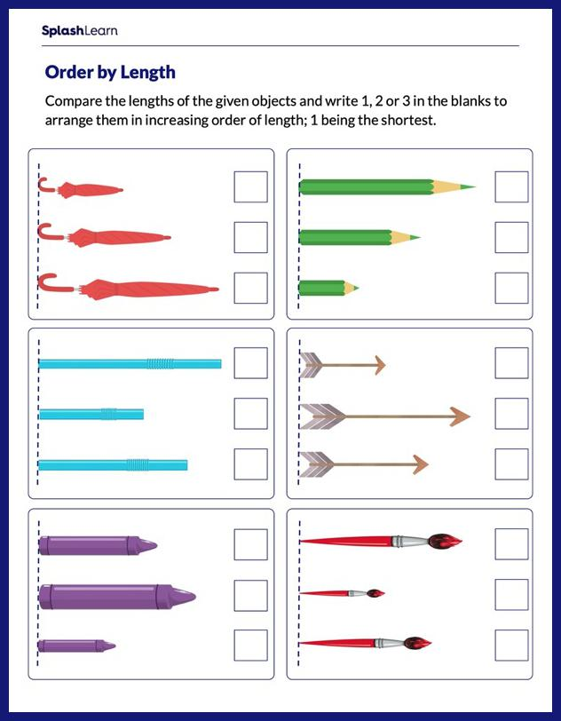
[18 marks]

Date: _______________
Comparing lengths, shortest to tallest.
Put the bottle in order from the tallest to the shortest.

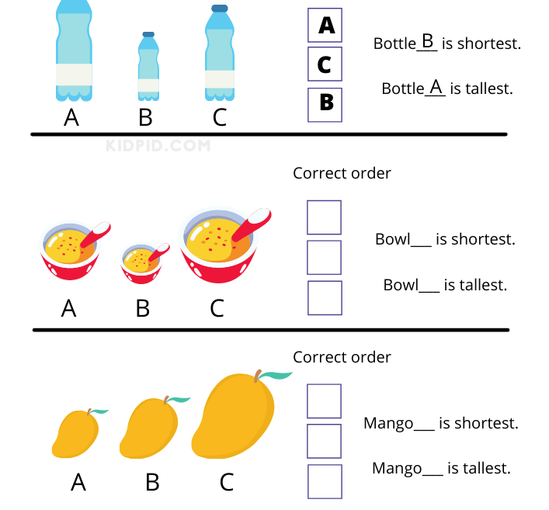
[6 marks]

Group 3
Date: _________________
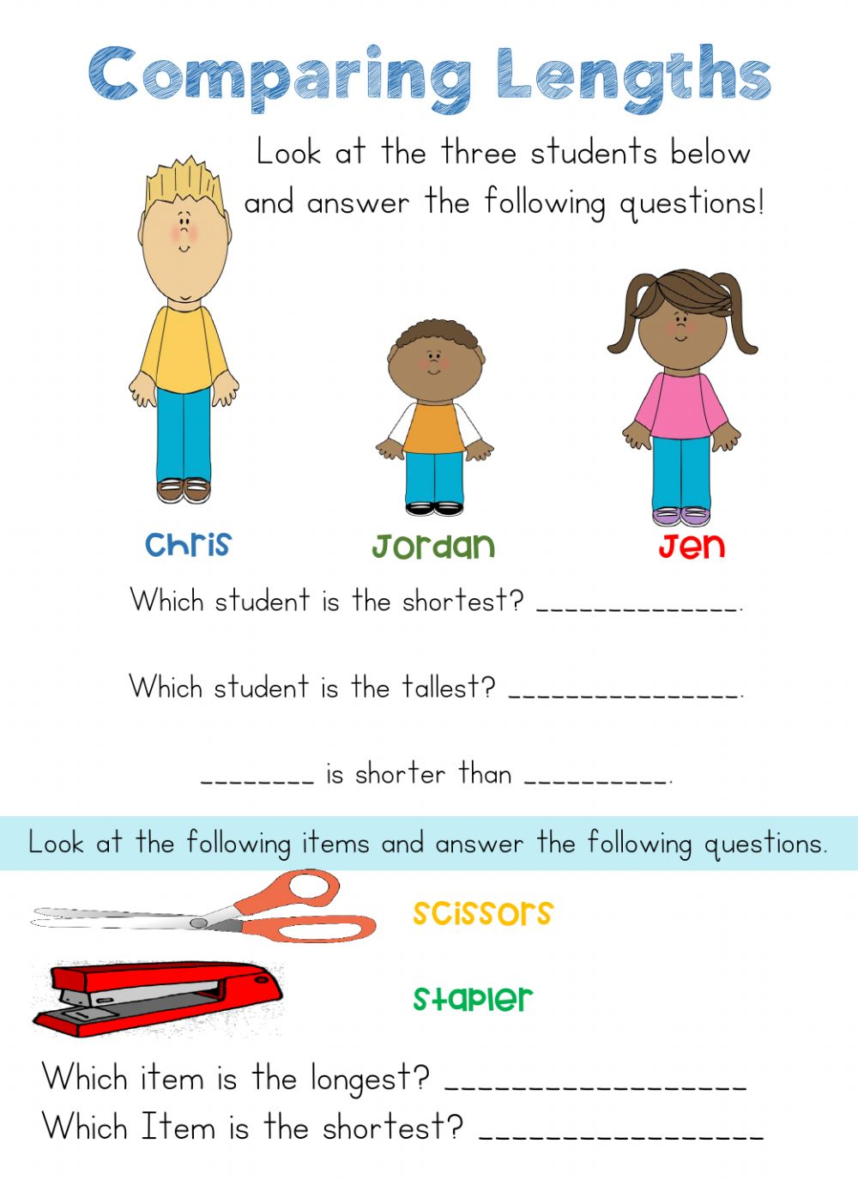
[7 marks]
Date: ______________
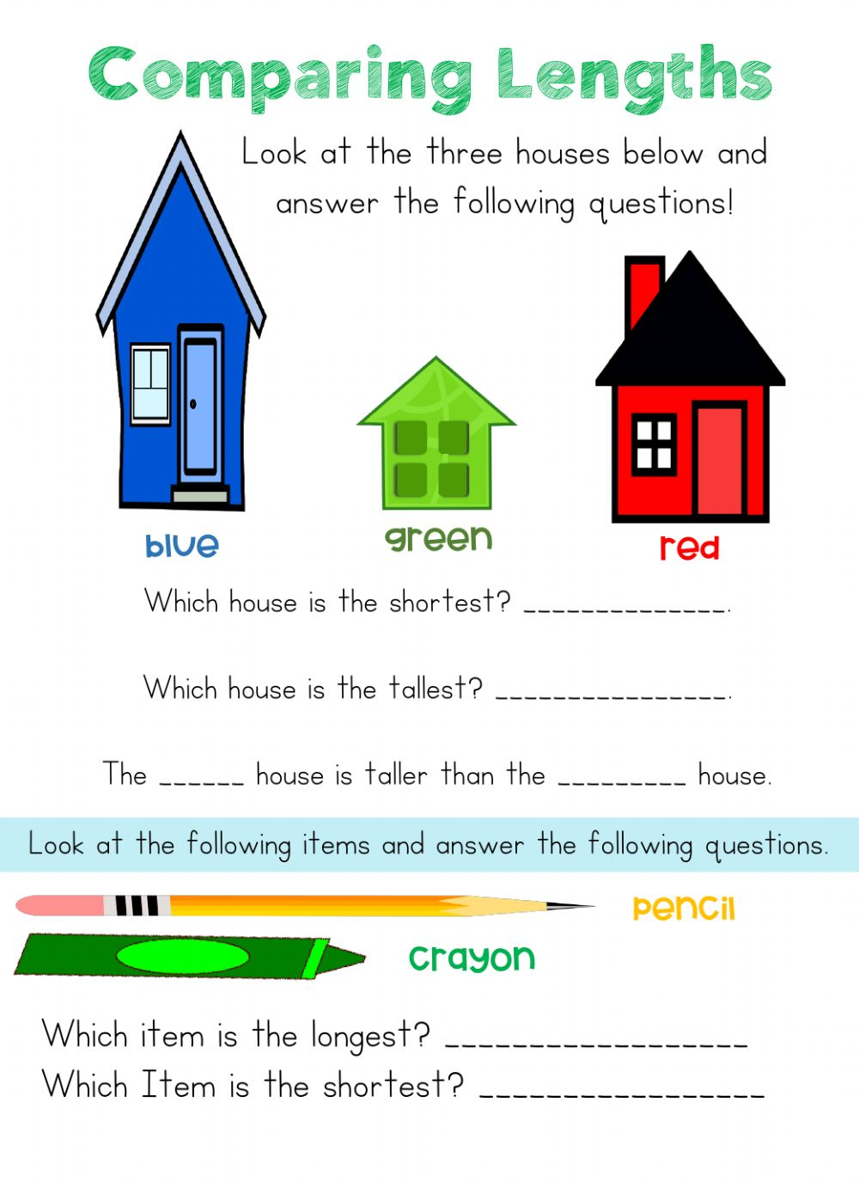
[6 marks]
Date: ______________
Measure the length of the school materials given below and write the answers.
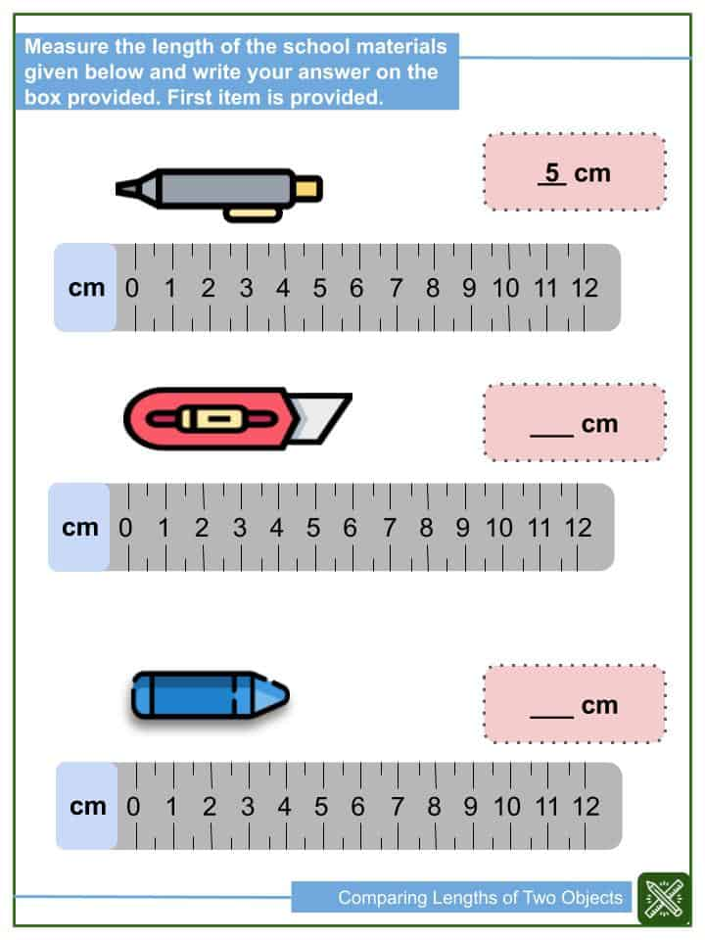
[2 marks]

Date: _____________
Comparing numbers up to 10
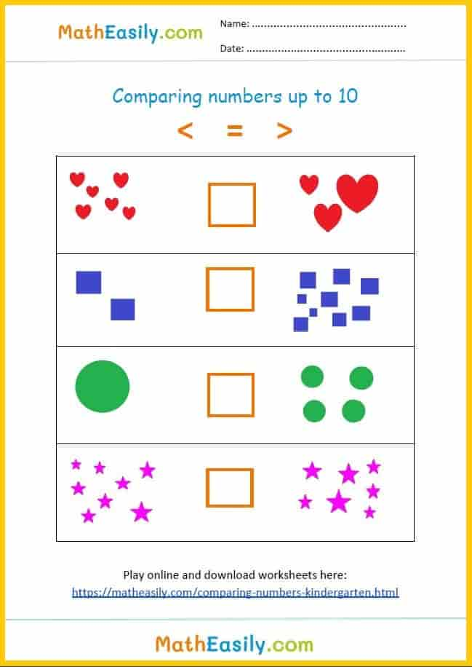
[4 marks]

Date: ______________
Complete the mathematical equation using > < =

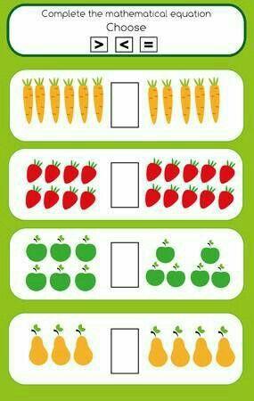
[4 marks]

Date: _______________
More, less or equals to?
< > =
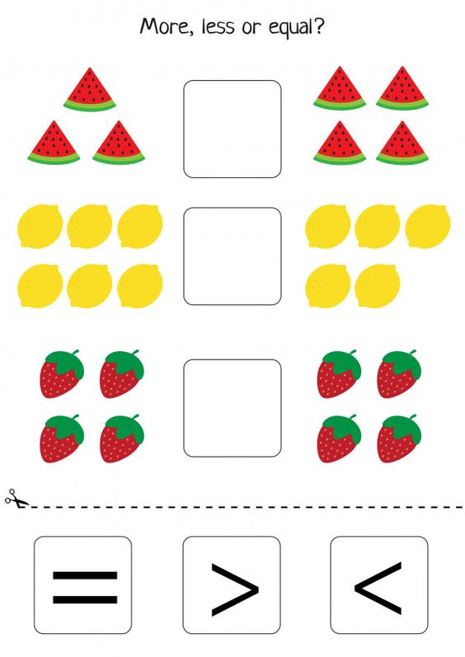
[3 marks]

Group 2
Date: _______________
Greater than or less than
Use the signs below to show which number is greater or the least.

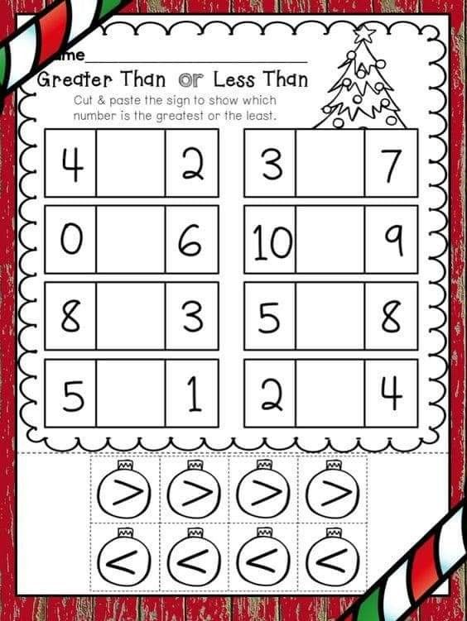
>
< [8 marks]
Date: _______________
Write the correct sign > < = in each circle.
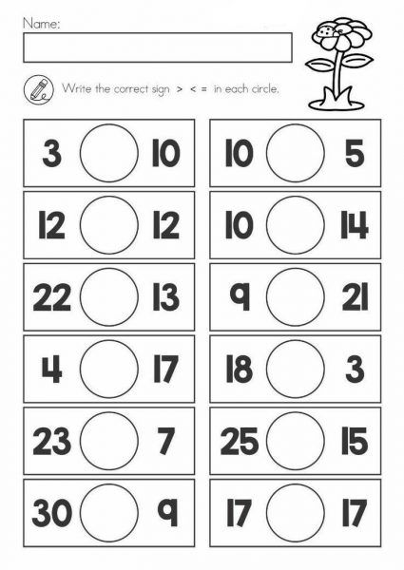
[12 marks]

Date: _____________
Comparing numbers
Write the correct symbol less than < greater than > or equals =to.

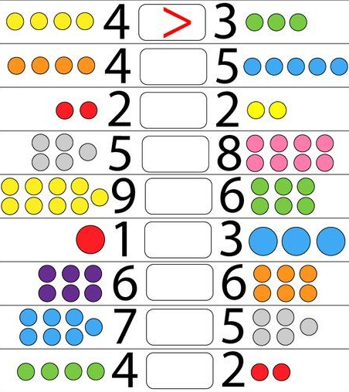
[7 marks]
Group 3
Date: _____________
Write the correct sign > < = in each circle.

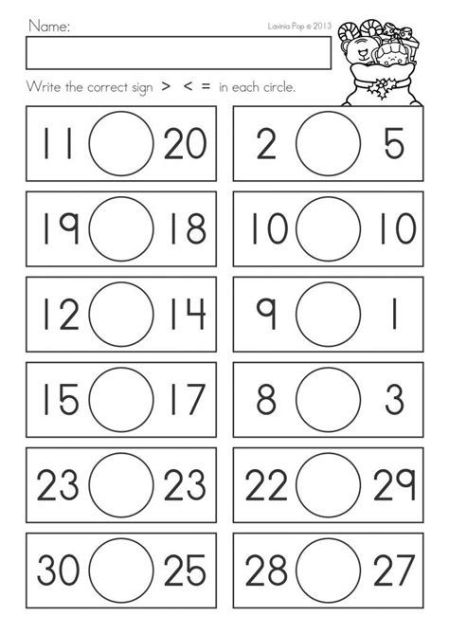
[12 marks]
Date: _______________
Write the correct sign > < = in each circle.

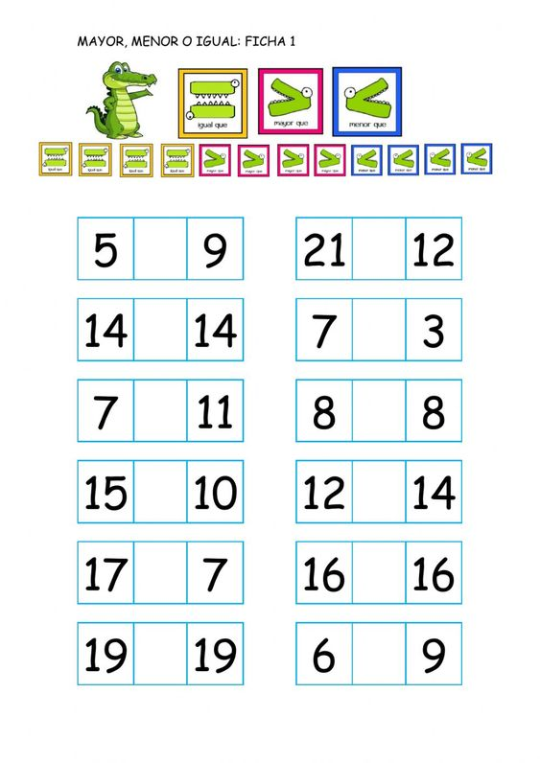
[12 marks]
Date: _____________
Greater than, less than, equals to
Fill in each circle with the correct sign.

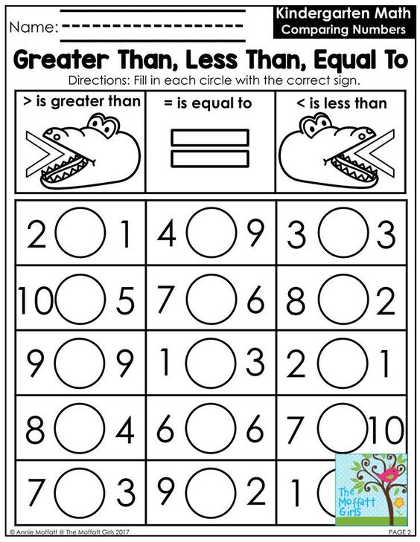
[12 marks]
Week 6

Group 1
Date: _____________
Colouring 2D shapes
Find the 2D shapes and colour.
circle | square | triangle | rectangle | Oval
green | blue | pink | brown | Red

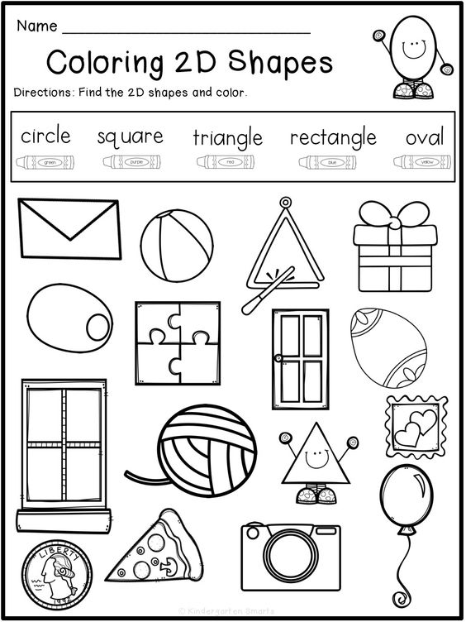
[8 marks]

Date: ______________
Match and colour
Match the correct shape with the object.

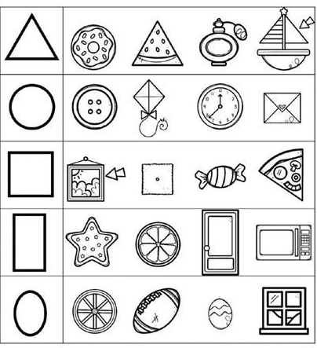
[6 marks]
Date: _______________
Colour and trace the 2D shapes

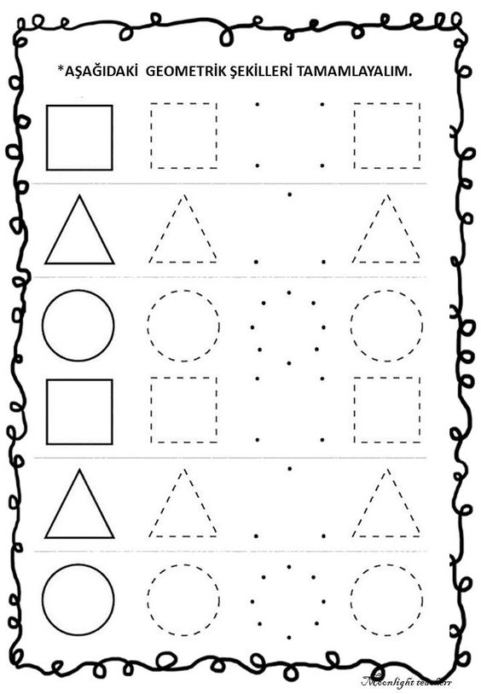
[10 marks]
Group 2
Date: ______________
2D shapes
Colour the 2D shapes using the colours below.

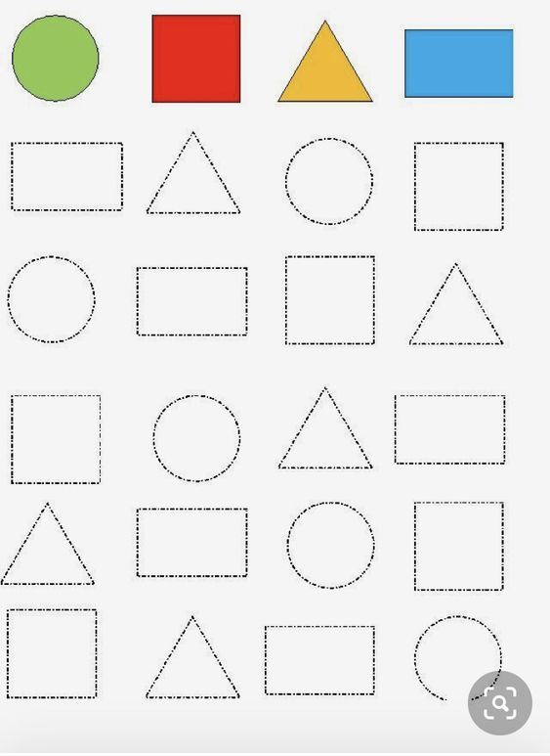
[10 marks]
Date: ______________
2D shapes
Match the shapes with the correct words.

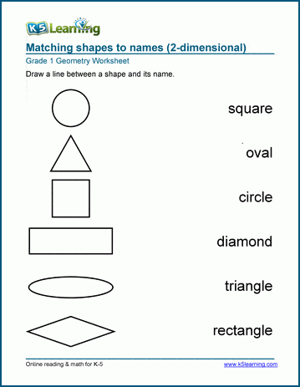
[6 marks]
Group 3
Date: ________________
Shape match
Match the names of each shape below
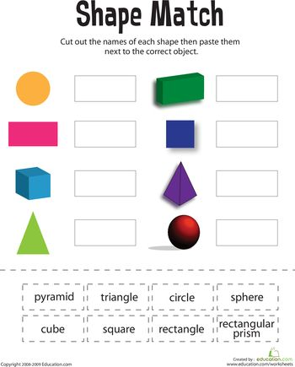
pyramid | Triangle | Circle | Sphere
cube | Square | rectangle | rectangular  prism
[8 marks]

Date: ______________
Write the names of the shapes
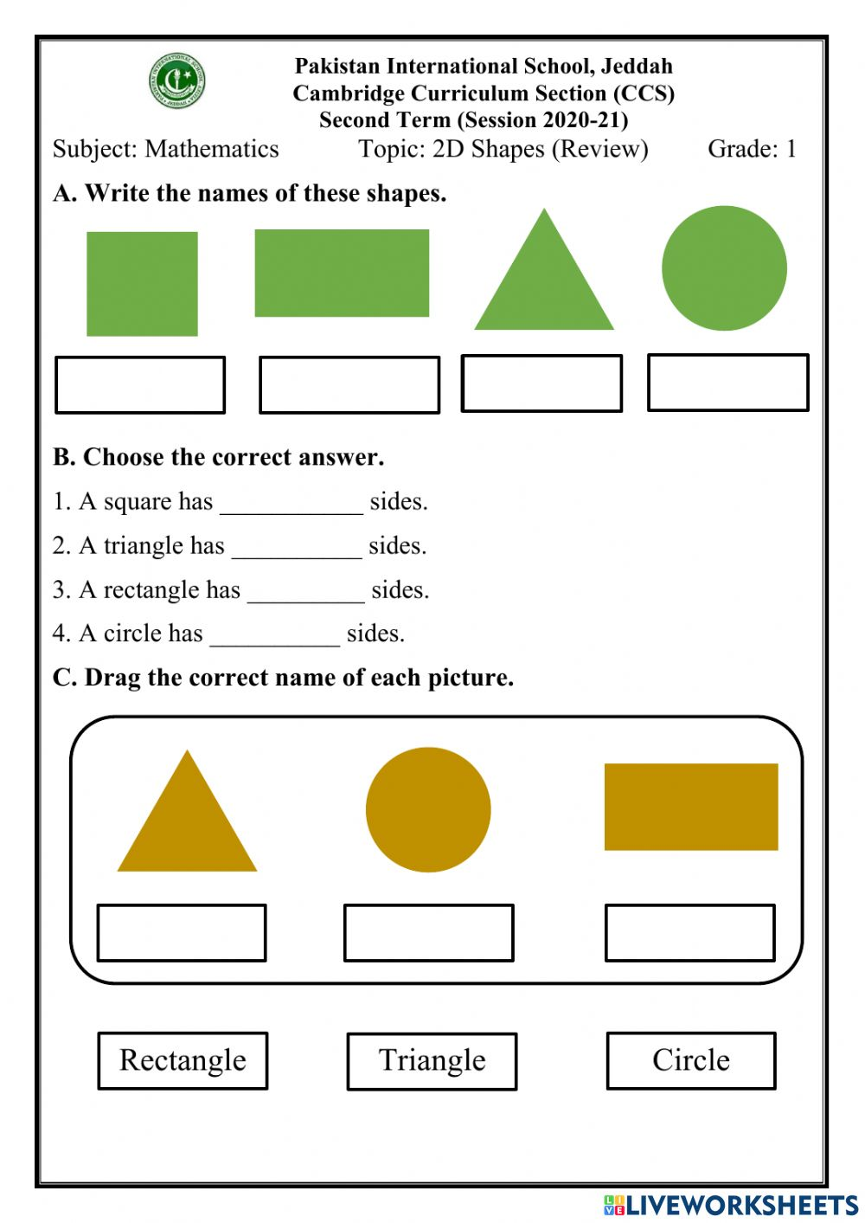
[11 marks]

Date: ______________
Read and follow the instructions below.

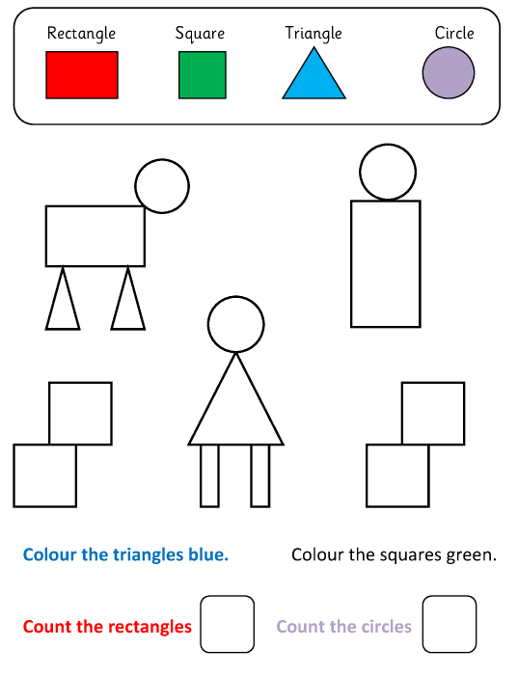
[15 marks]
Week 7

Group 1
Date: _______________
Odd shape out
Look at each picture on the left. Check the shape that is not used in the picture the make a cross.

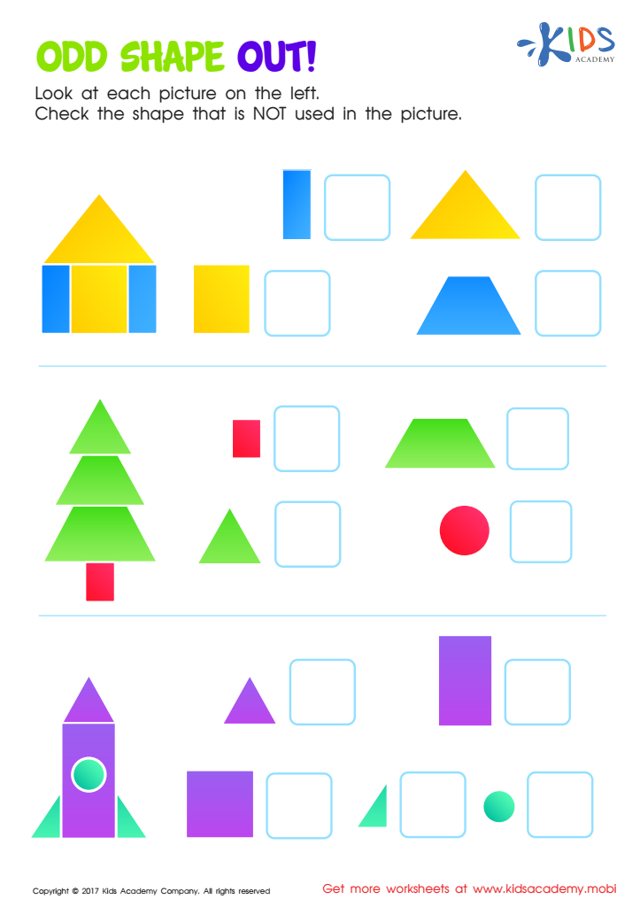
[10 marks]

Date: _____________
Draw a line to match the correct shape.

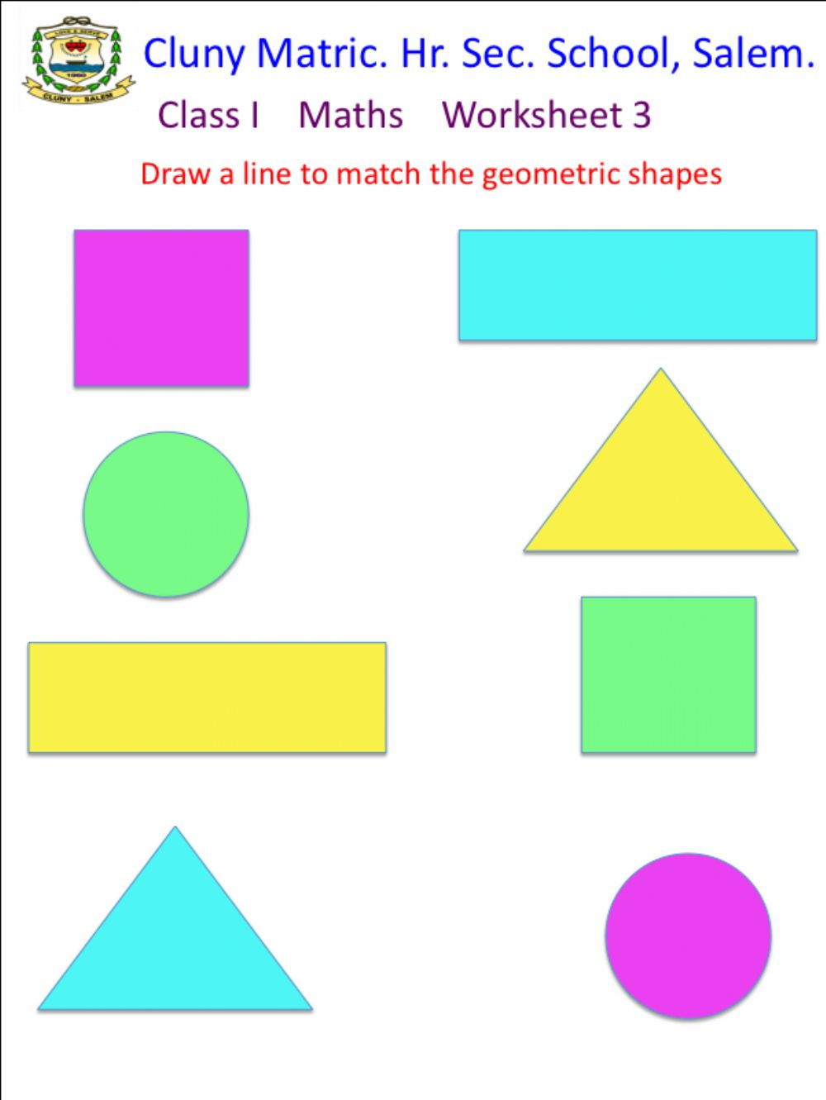 [5 marks]

Date: _____________
2D Shapes
Match the shapes to their names.

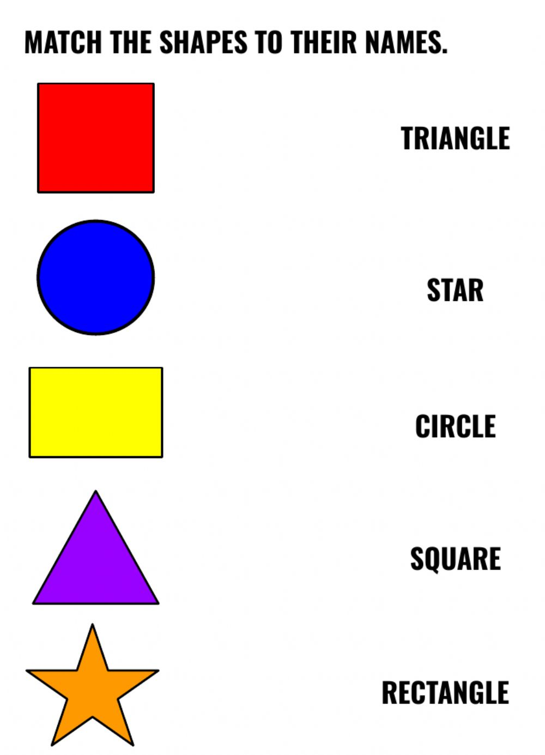 [5 marks]
Group 2
Date: ____________
Triangular shape
How many triangles.

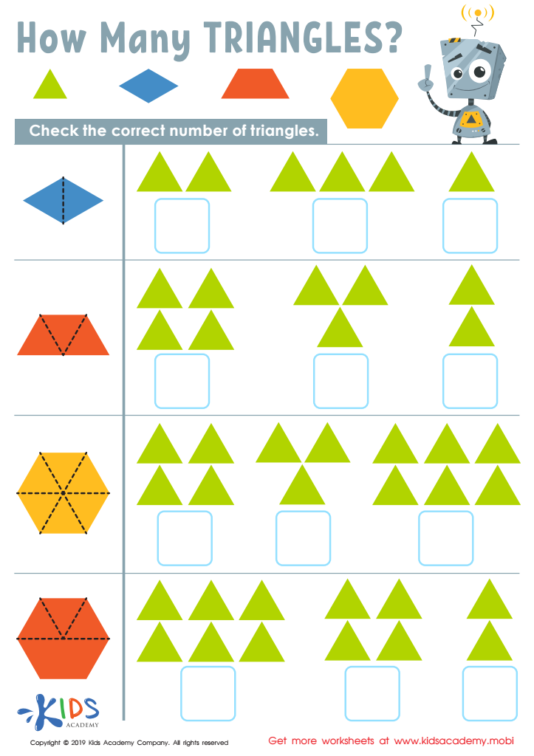
[12 marks]
Date: ______________
2D shapes
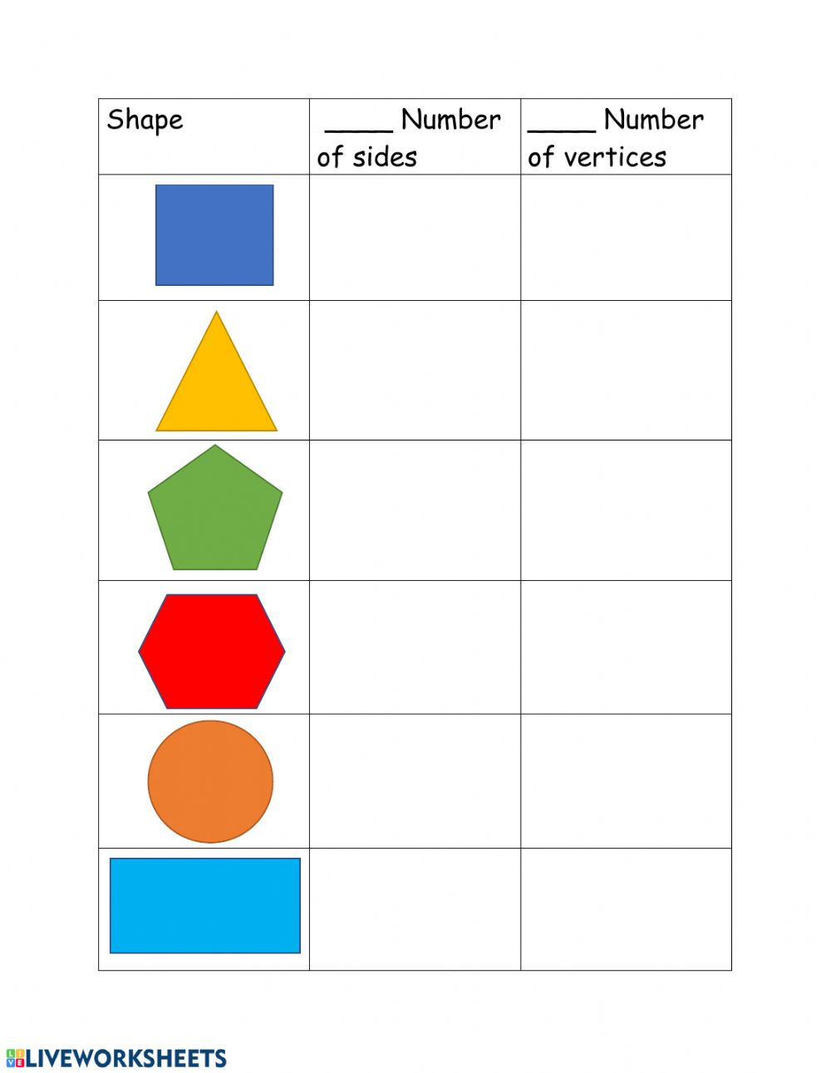
[6 marks]

Date: _______________
Shapes
How many sides?

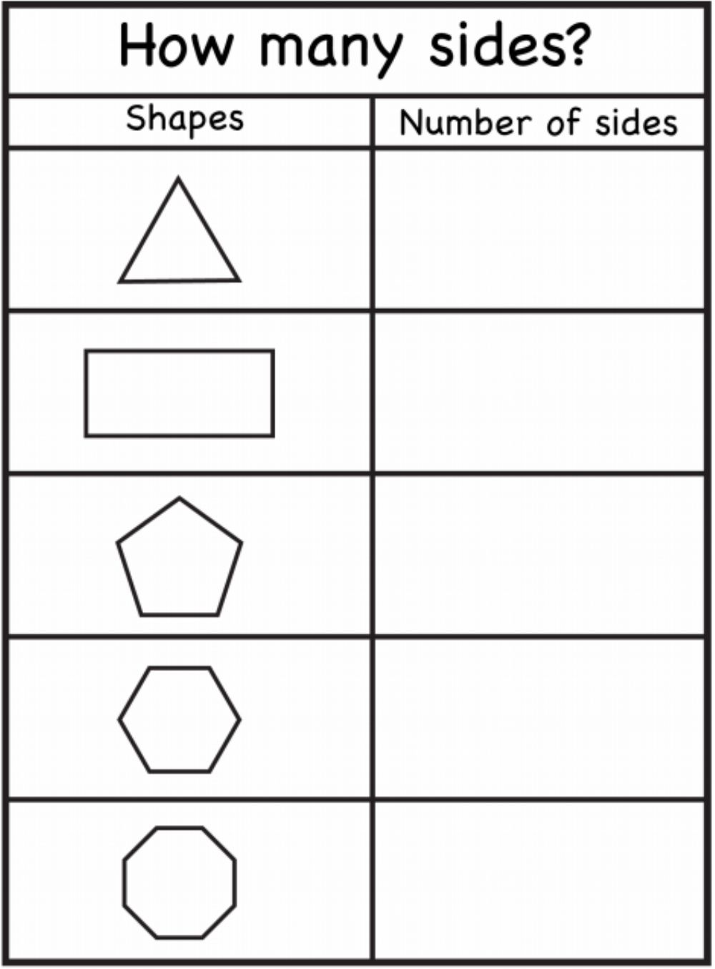
[5 marks]
Group 3
Date: _______________
2D shapes
Name the shapes and write how many sides and how many corners.

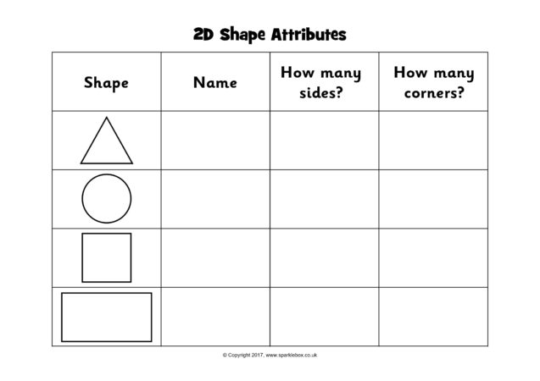 [12 marks]

Date: ______________
2D shapes activity
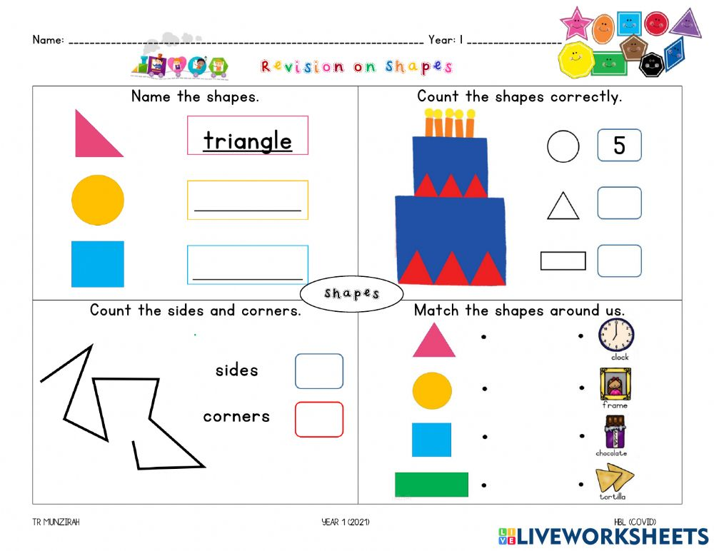
[10 marks]

Date: _______________
2D shapes Attributes

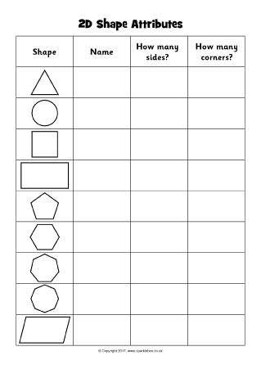

[27 marks]

Week 8

Group 1

Week 9

Group 1
Date: _______________
Addition
Find the sum for each a
Addition problem. use the sum to find the correct colour at the bottom.

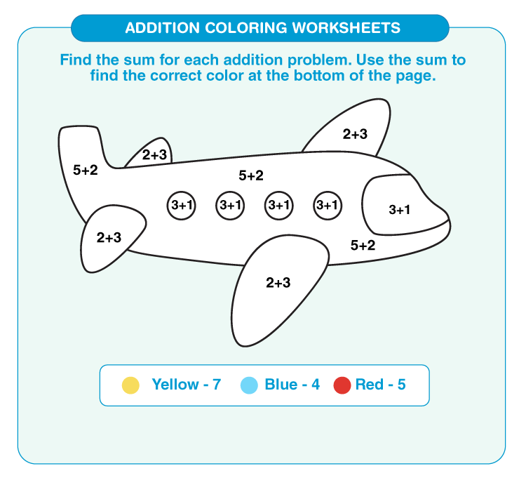
[3 marks]
Date: ______________

Subtraction
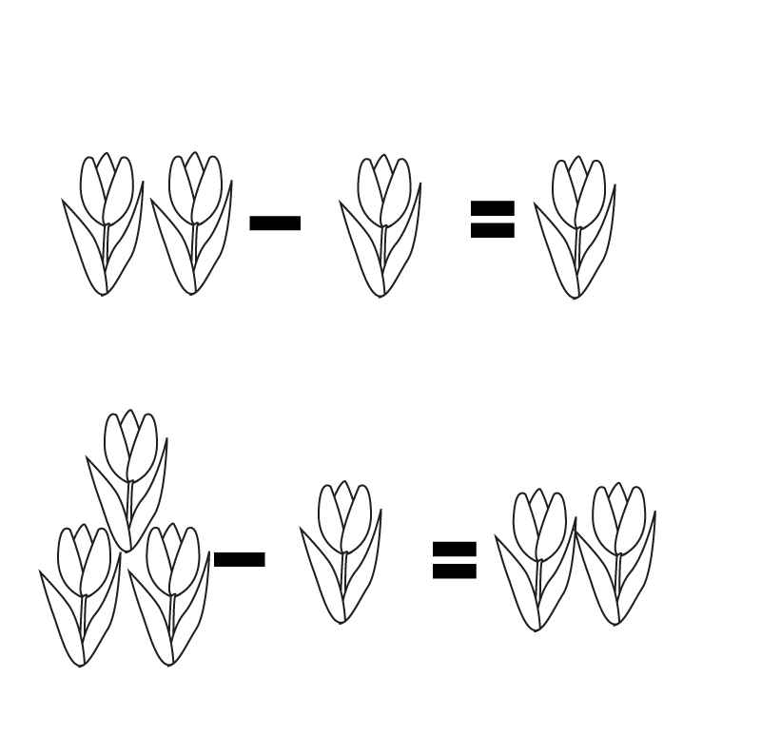
[2 marks]

Date: ______________
Addition
Find the sum for each addition problem. use the sum to find t5he correct colour at the bottom.
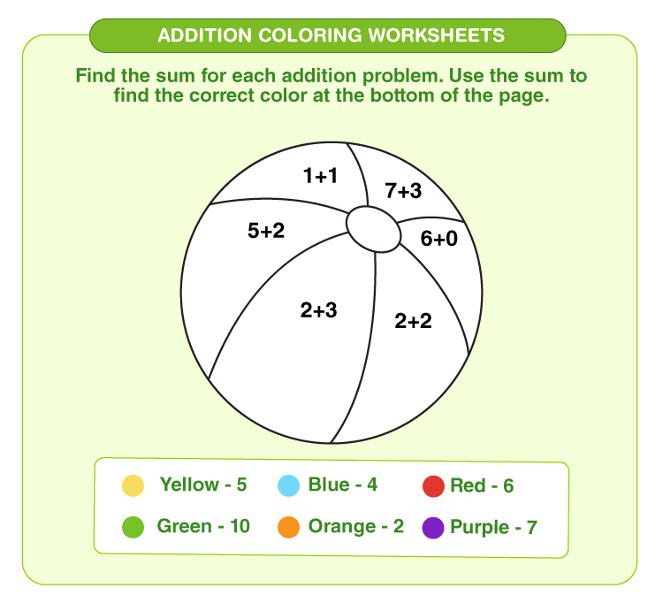
[3 marks]
Group 2
Date: ______________
Find the missing number and solve the equation below.
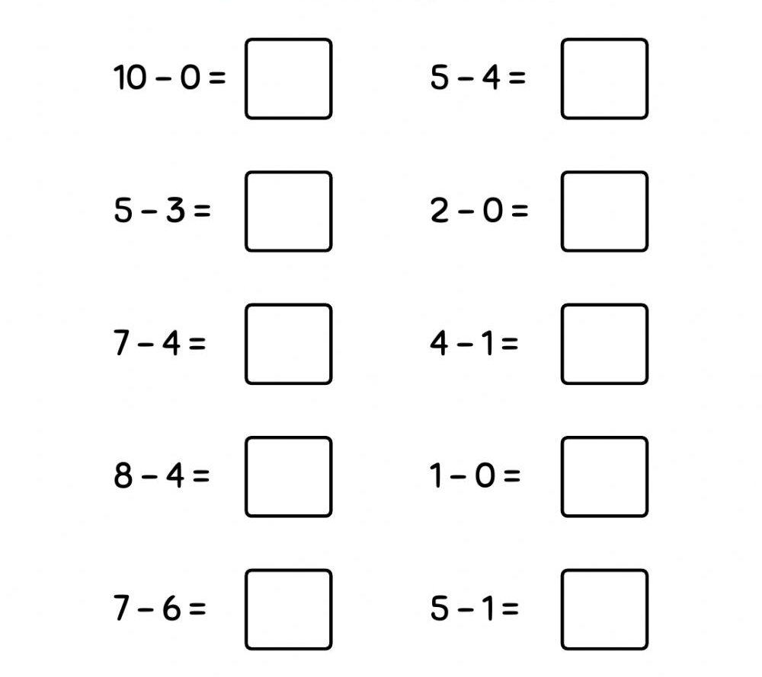
[10 marks]

Date: ______________
Addition to 20
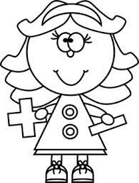

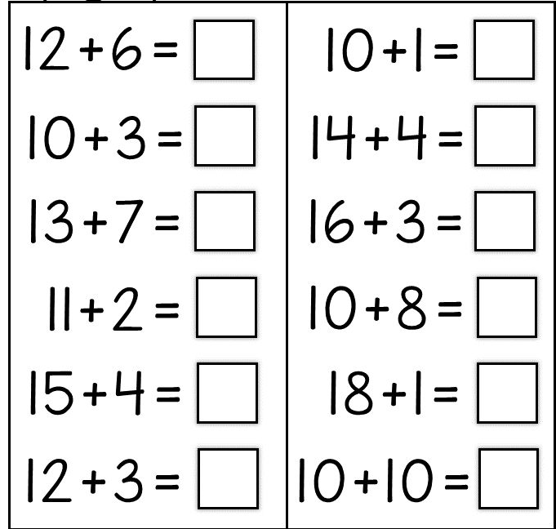
[12 marks]

Date: ______________
Addition to 10
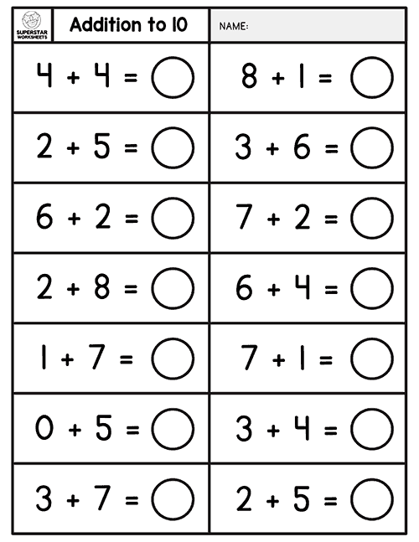
[12 marks]
Group 3
Date: ______________
Subtraction

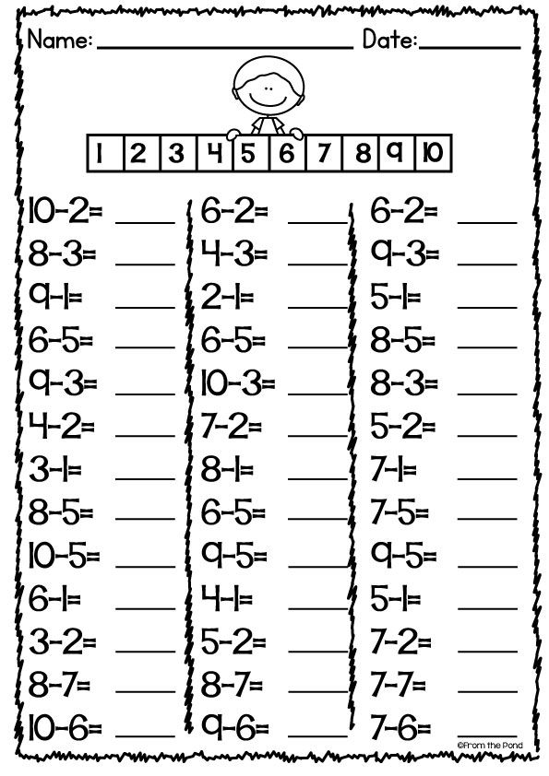
[ 33 marks]
Date: ______________
Simple addition and subtraction.
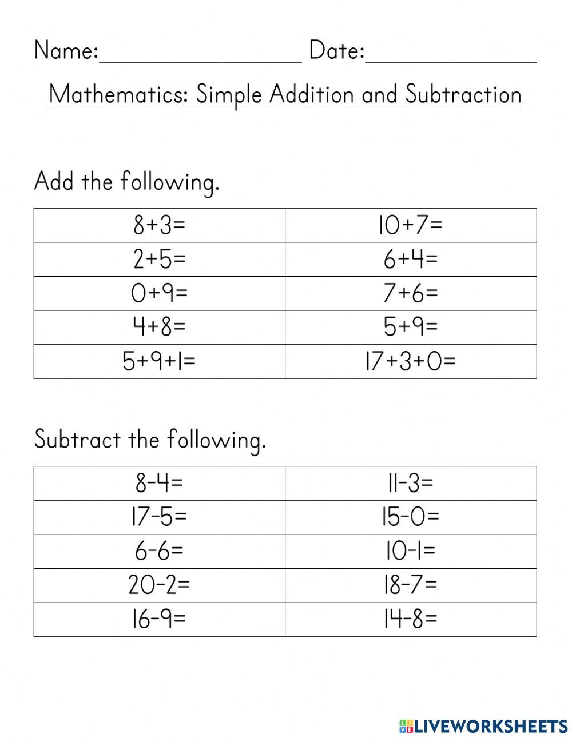
[20 marks]

Week 10

Group 1
Date: _________________
Add the objects and write the correct answer.

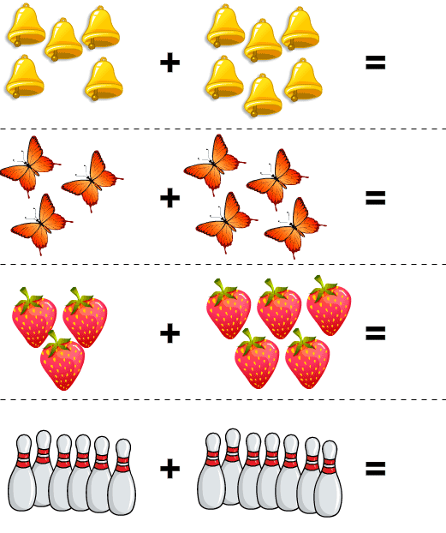

[4 marks]
Date: _______________
Add the objects and write the correct answer.

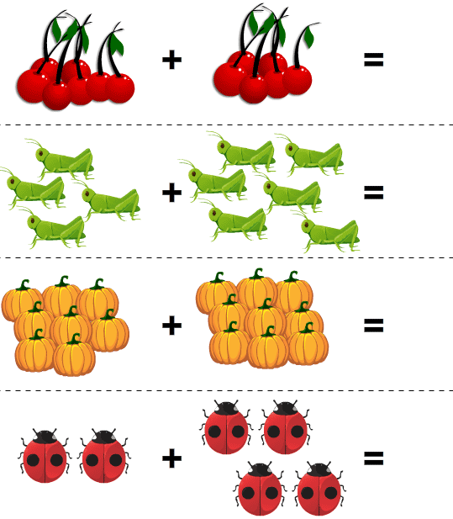

[4 marks]
Date: _______________
Count, sum and circle the correct number

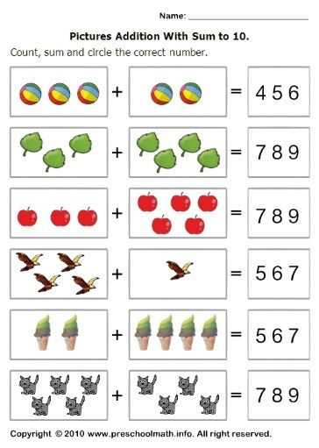

[6 marks]

Group 2
Date: ______________
Word problems
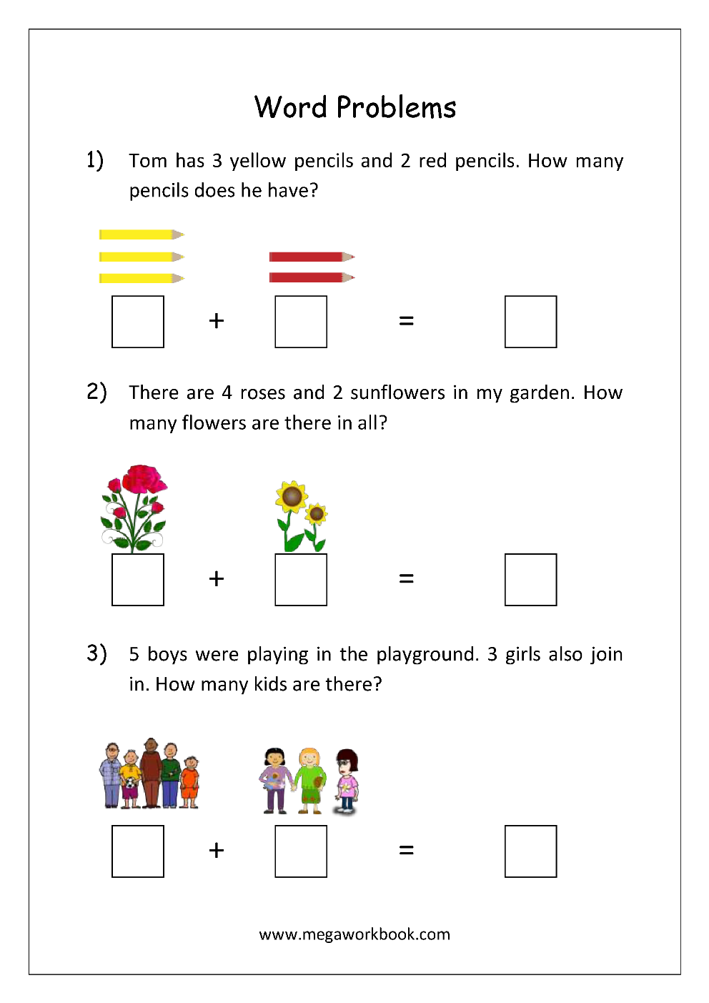
[6 marks]

Date: _____________
Word problems

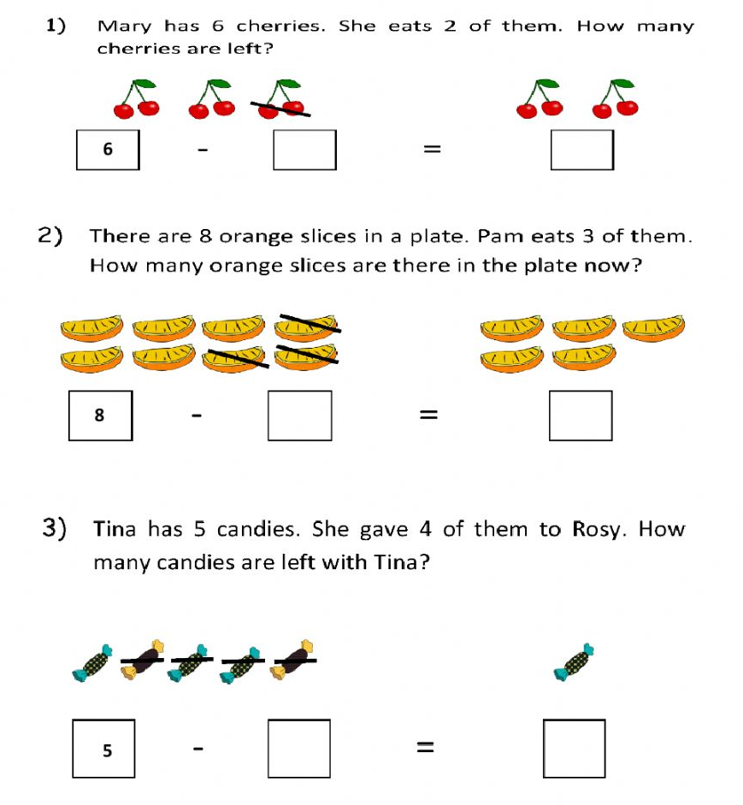
[6 marks]

Date: _______________
Addition and subtraction problem solving.

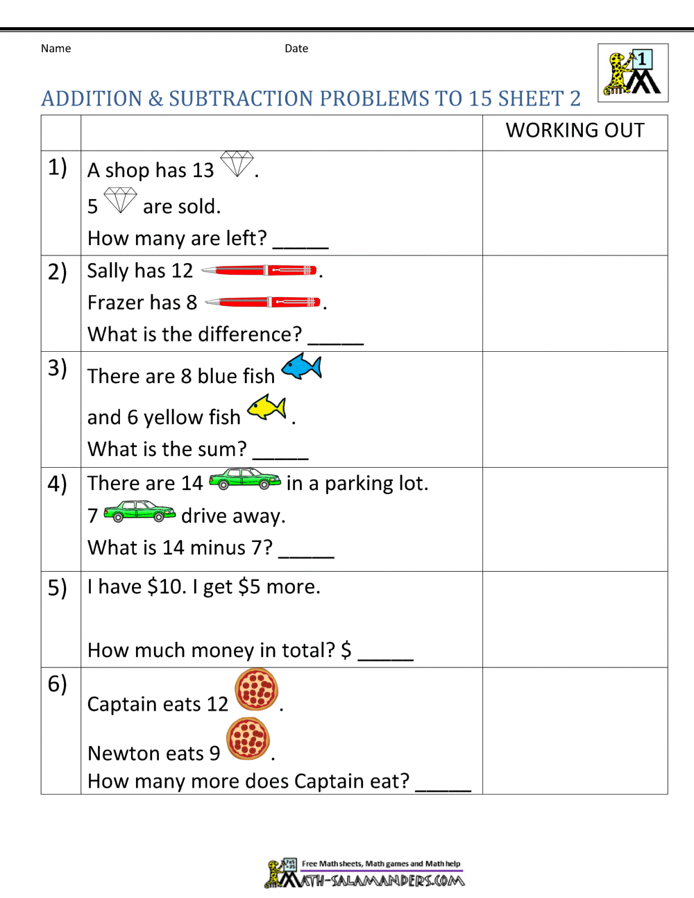

Group 3

Date: _______________
Problem solving worksheet
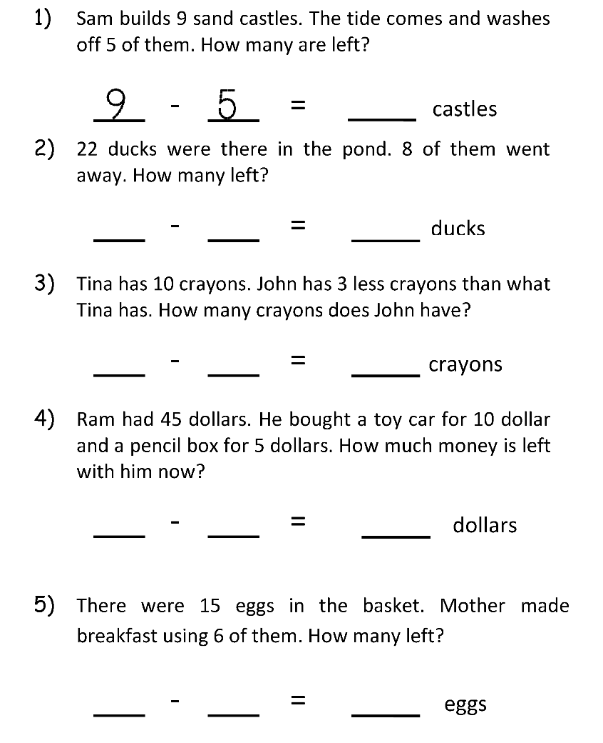
[13 marks]
Date: _______________

Problem solving subtraction
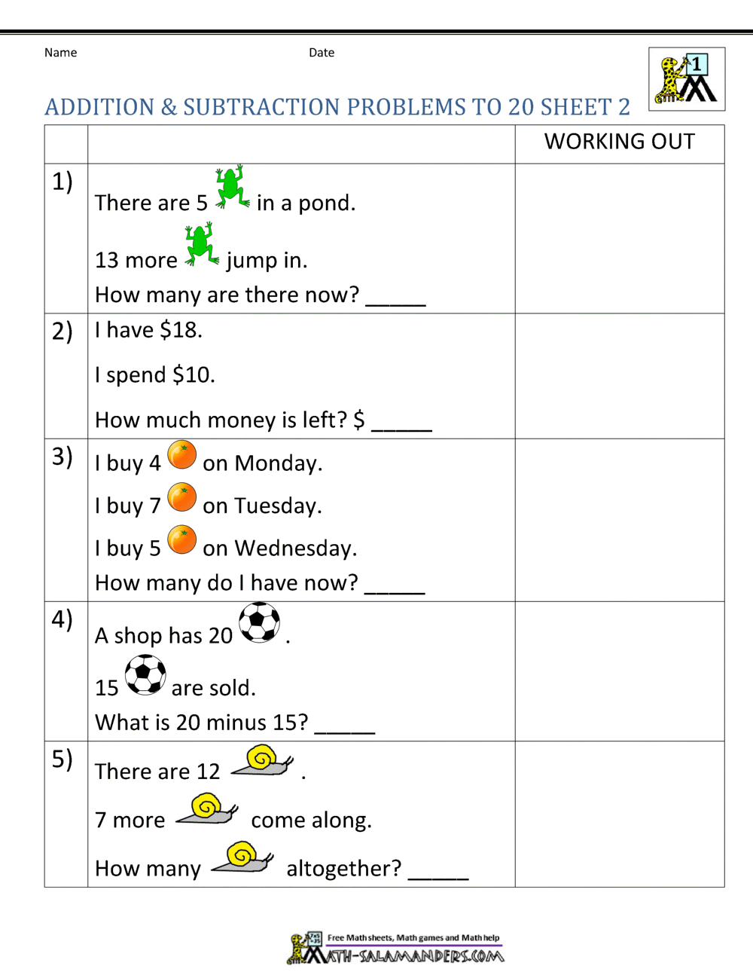
[5 marks]

Date: ________________
Addition word problem
Instructions: Read each word problem. Count the picture to find the sum.

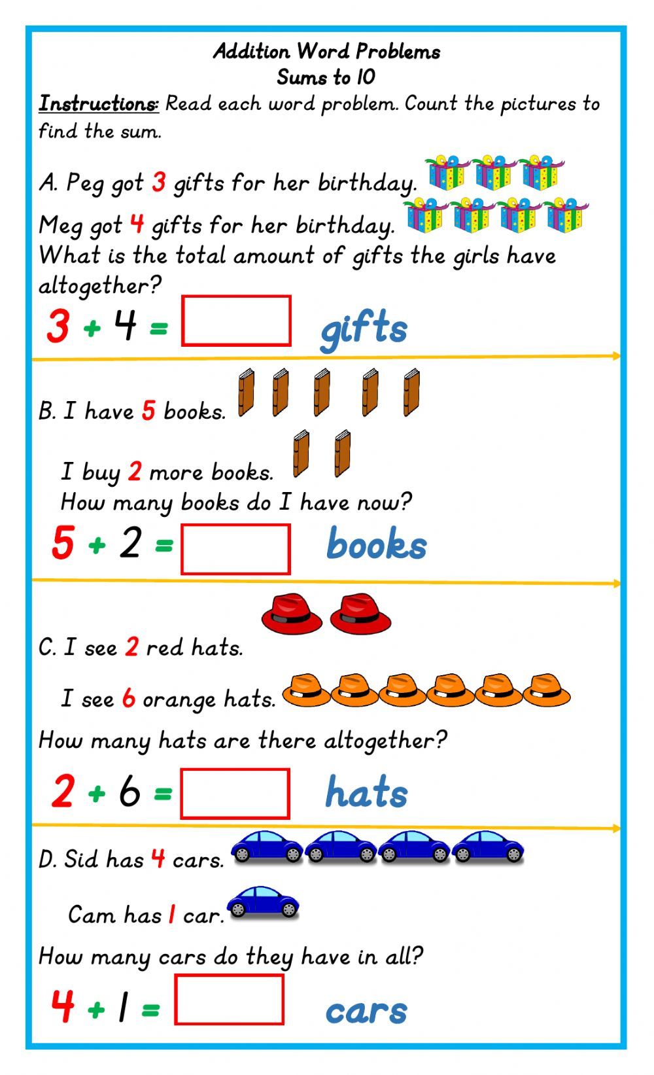

[4 marks]
Notes
____________________________________________________________________________________________________________________________________________________________________________________________________________________________________________________________________________________________________________________________________________________________________________________________________________________________________________________________________________________________________________________________________________________________________________________________________________________________________________________________________________________________________________________________________________________________________________________________________________________________________________________________________

The End

Acknowledgments
“Develop success from failures. Discouragement and failure are two of the surest stepping stones to success.” Dale Carnegie

Mathematics workbook was compiled by Treggy Nonkululeko Banda

- Fleisch, B. 2008. Primary Education: Why South African School Children Underachieve Mathematics. South Africa: Shumani.

- Guide

- Howie, S.J. 2006. Multi-Level Achievement of South African Pupils in Mathematics. In Howie, S.J. & Plomp, T. (eds). Contexts of Learning and Science. Oxon: Routled

- Mathematics Curriculum and Assessment Policy Statement Grade R-5 for learners with Severe Intellectual Disability.

- Pinterest

- Resources

- The Nation‟s Report Card (NAEP). 2004. Trends in Academic Progress. Three Decades of Student Performance in Reading and Mathematics. U.S. Department of Education.Institute of Education Sciences.

